 

**UNIVERSITY OF EDUCATION, WINNEBA**

**KOMENDA COLLEGE OF EDUCATION**

**STUDENT NAME : ABIGAIL AWUAH**

**INDEX NUMBER : 2121487**

**PROGRAMME : B.ED EARLY GRADE DEVELOPMENT**

**SCHOOL VISITED: KOMENDA M/A BASIC SCHOOL**

**LEVEL OBSERVED: BASIC ONE (B)**

**HEAD TEACHER NAME : MR. ALBERT KWOFIE**

**NAME OF MENTOR : MADAM JOSEPHINE**

**COURSE TITLE : FEILD EXPERIENCE**

**DISTRICT: KOMENDA EDENA EGYUAFO ABREM (KEEA)**

**CIRCUIT : KOMENDA**

**S.T.S SUPERVISOR : MR. ERIC SEKYI**

**STUDENT REFLECTIVE JOURNAL**

**JUNE, 2022**

**TEACHING PHILOSOPHY STATEMENT**

Teaching is an act of imparting knowledge from more experienced person to less experience person. Philosophy is a view or outlook regarding fundamental principles underlining some domain. Teaching philosophy is a self-reflective statement of your believes about teaching and learning.

As an early grade teacher, I believe that, family relationship are essential component of our education system.

I hope that through my teaching I can provide student with the opportunity to learn life skills, exercise creativity and think about the world around them.

Regardless to discipline, I hope to create a classroom environment where student will feel safe, accepted, supported and encourage student irrespective of thier backgrounds, gender, religion, ethnicity, physical and mental ability.

I intend to make my classroom a place where all student is accepted and valued for who they are and given a safe space to make connection, grow and to build confidence.

As an early grade teacher, I hope to impact student with the pertinent skills that will help them succeed in life. As a teacher, I hope to equip them the skills and the knowledge to manage thier life and thier family living. Am not only to teach them about the subject matter but the relevance to thier present life's that can be of constant use as they grow. I will also allow student to acquire the necessary skills, for instance, decision making, social and communication skills which are deemed as critical qualities for occupational success. All these are polished through the execution of course work where the teacher takes the role as facilitator to guide the students in exploiting the project.

**DAY ONE**

**FAMILIARIZATION AND ORIENTATION**

The school I visited was Komenda M/A BASIC School. I arrived at 8:00am on 13th June, 2022. I and my fellow colleagues went there to familiarize and observe with the school activity environment as first activity of supported teaching in school. The headmaster then oriented us about the school compound where we took some photographs of the compound. He then gave us a brief history about the school. Upon the headmaster, He enlightened on the school history and mainly the agenda for the induction. He explained the agenda of the school to us prior to our meeting with the headmaster. He said the reading and writing document policy is all about the inclusive education policy of children who are physically challenged and are to join those who are not challenged physically in the school for progress.

**THE SCHOOL PROFILE**

Komenda M/A KG/Primary A and B. This indicates that the school has two(2) streams(stream A and stream B). There are sixteen(16) teaching and learning classrooms in the school. The learners population stands currently at 879 pupils, out of this number, 439 are from stream A and 440 are from stream B. The total number of female learners are 460 and males are 419. There are two(2) categories of staff in the school, these are teaching and non-teaching staff. Total number of teaching staff are 18, out of which 13 are females and 5 are males. The school has two(2) NABco personnel and they are all females and 1 national service personnel. The ten(10) non--teaching staff are responsible for the school feeding program.

Other facilities of the school apart from the classrooms are one(1) kitchen for school feeding program, one staff common room for teachers, one library for the learners, two(2) office complex, one for the headmaster and the other for the assistance, 14 toilets facility rooms for the learners and two(2) for the staff, one(1) dinning Hall for nursery learners and 1 canteen for the sellers. The school has a cadet club, life skills club, science and maths club, reading club. Again, the has won several awards in netball(always first), volleyball and soccer ball.

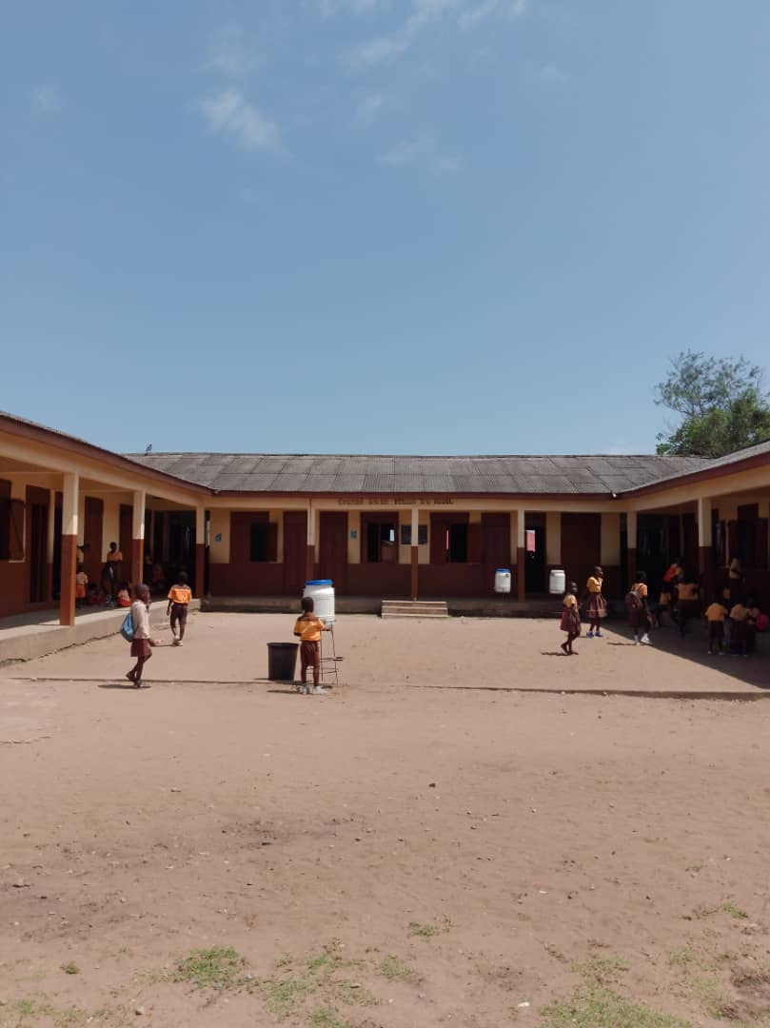**FRONT VIEW OF THE SCHOOL 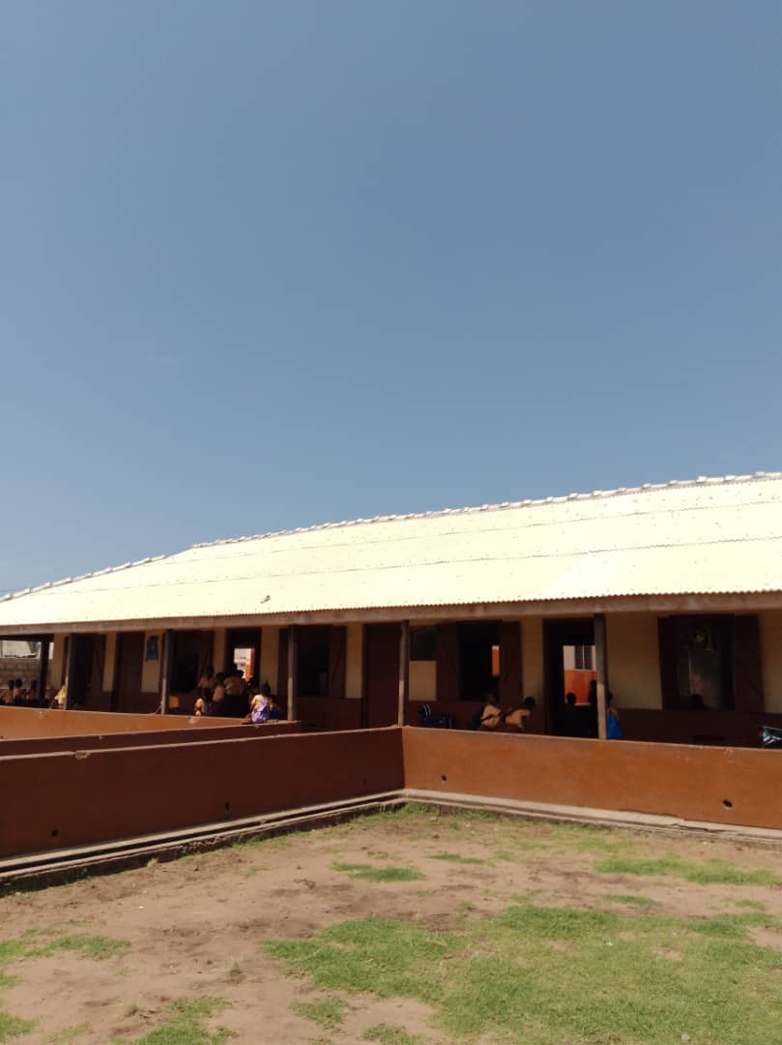FRONT VIEW OF THE SCHOOL**

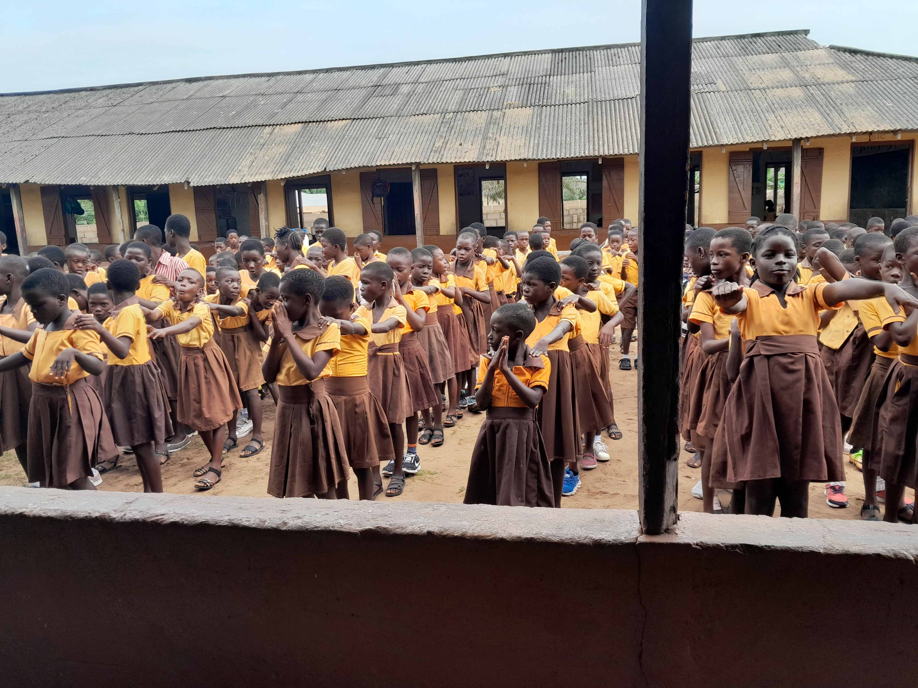 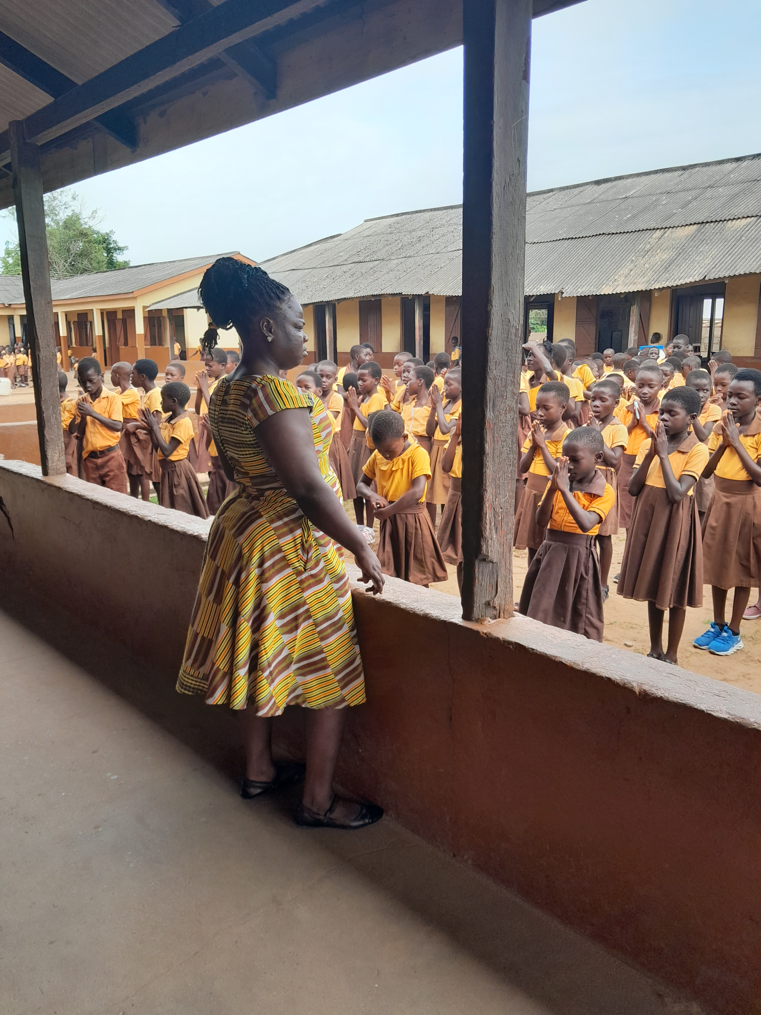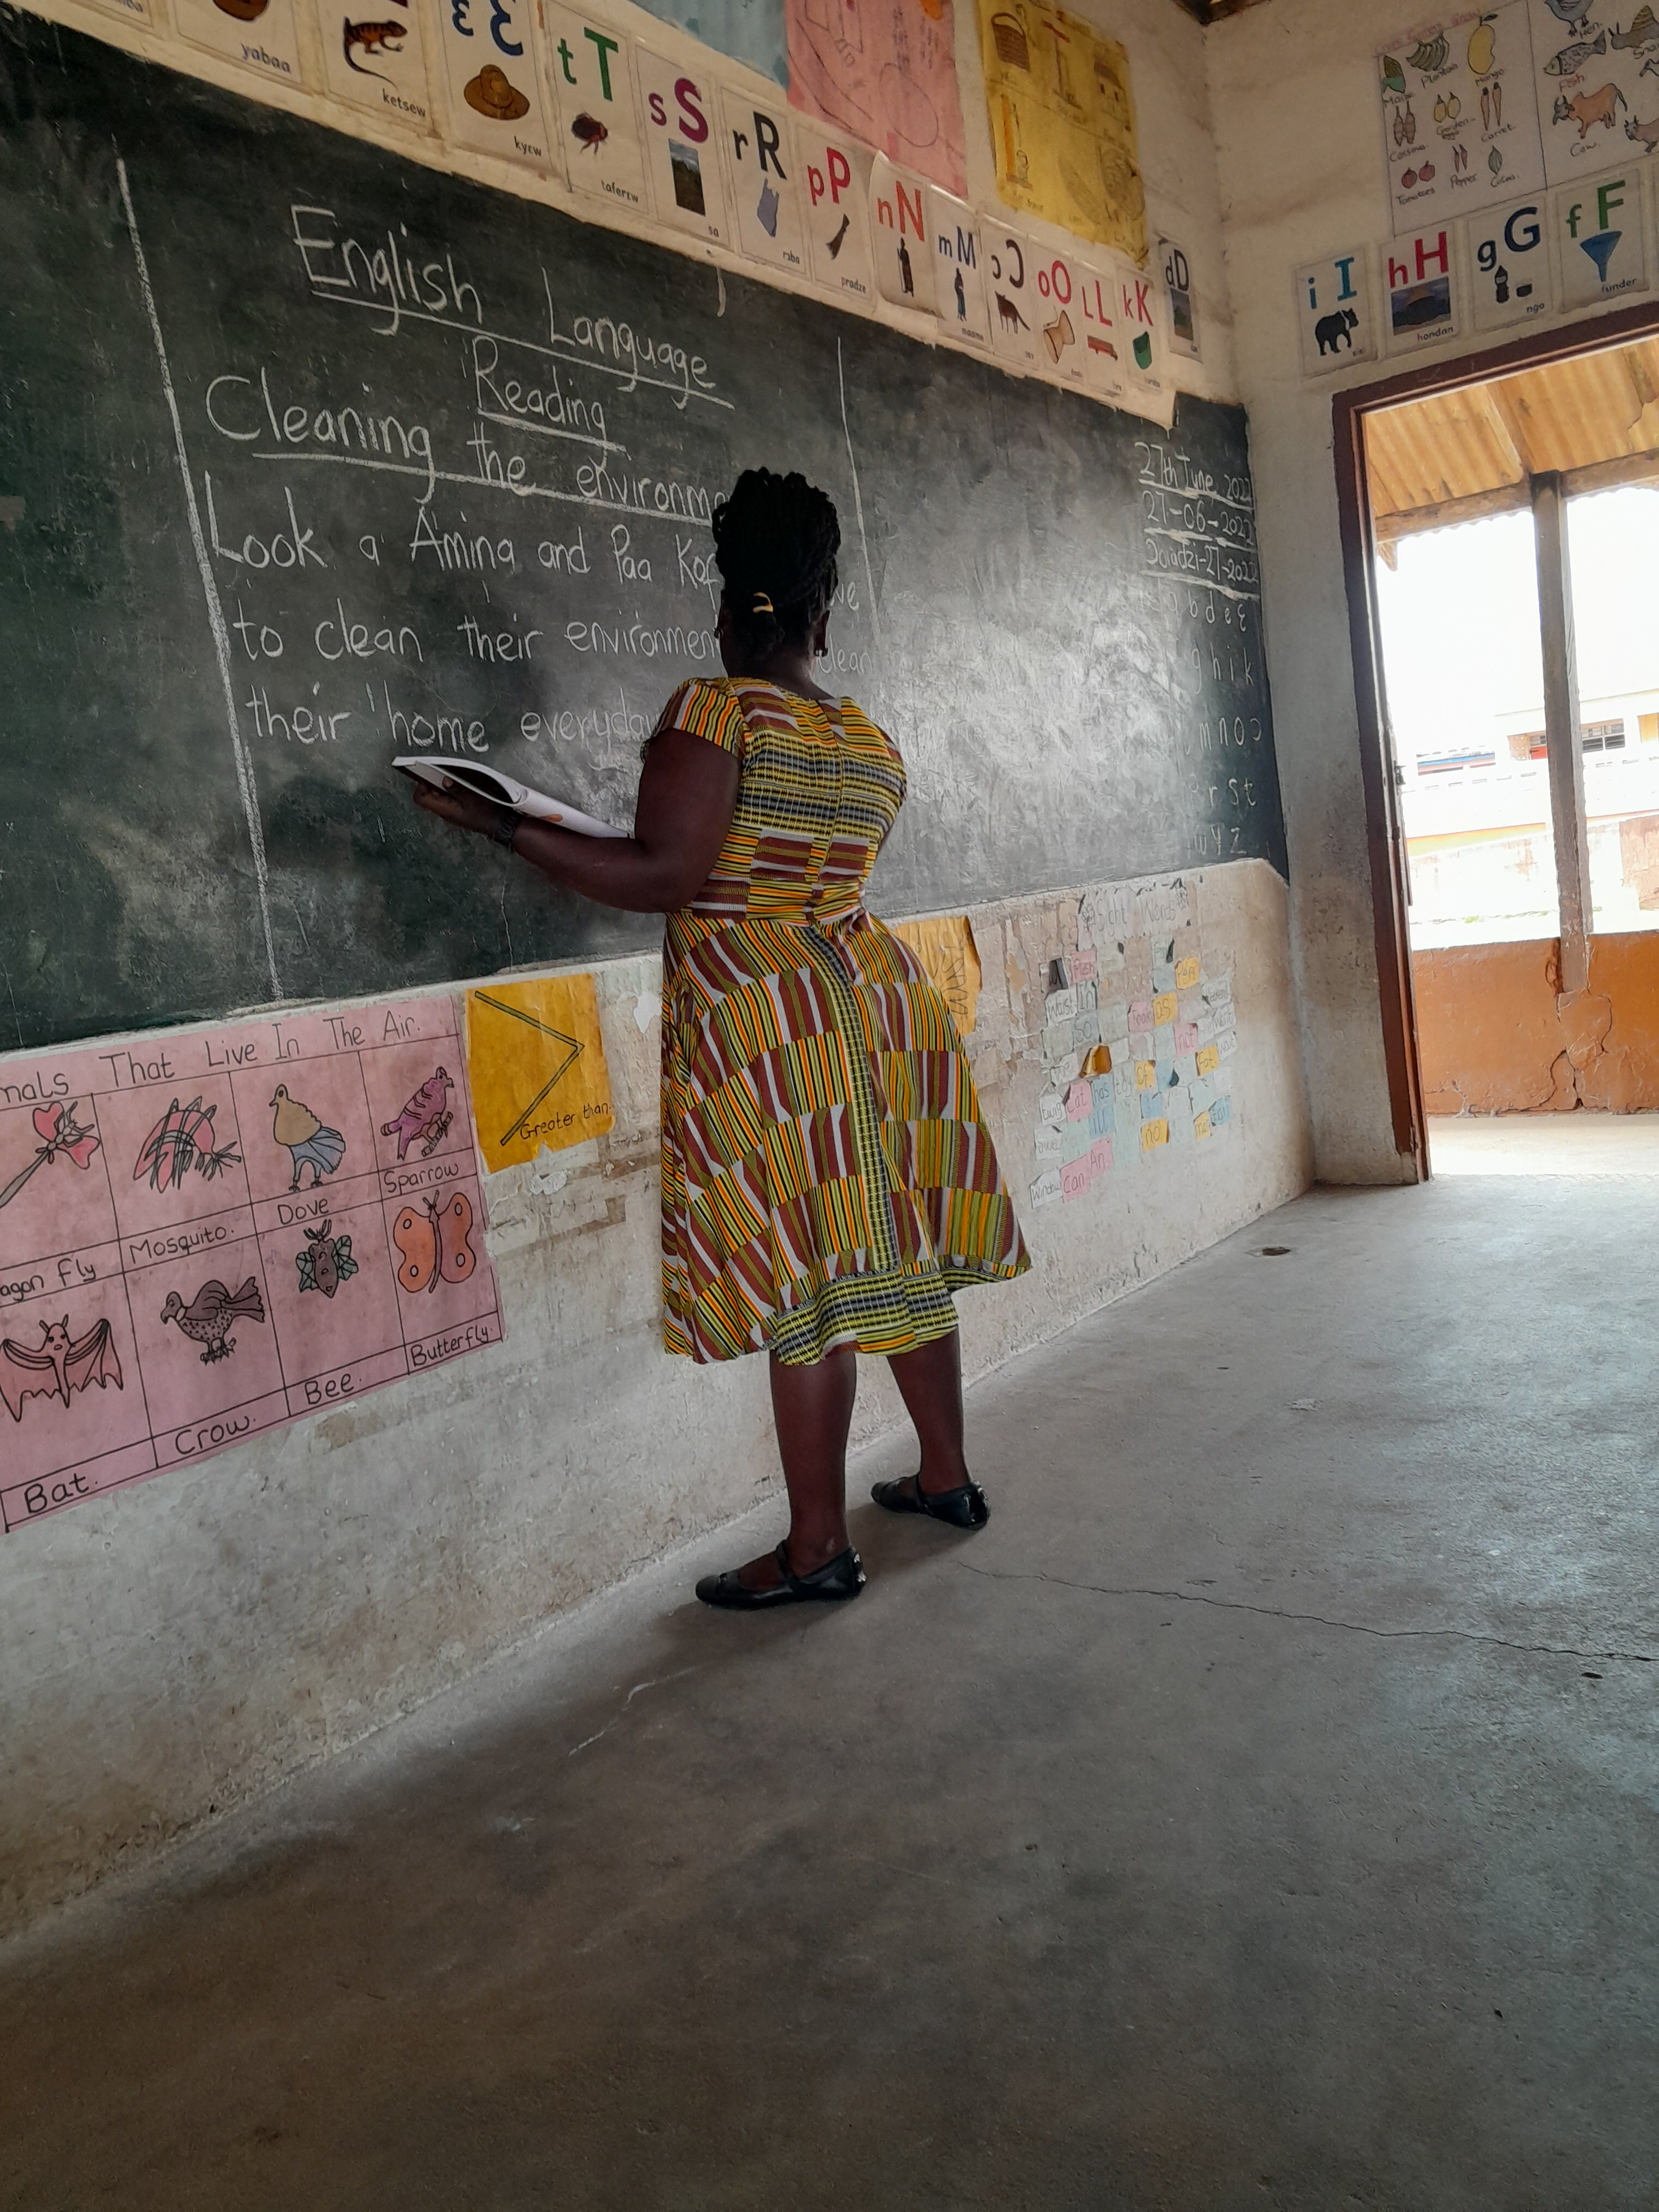 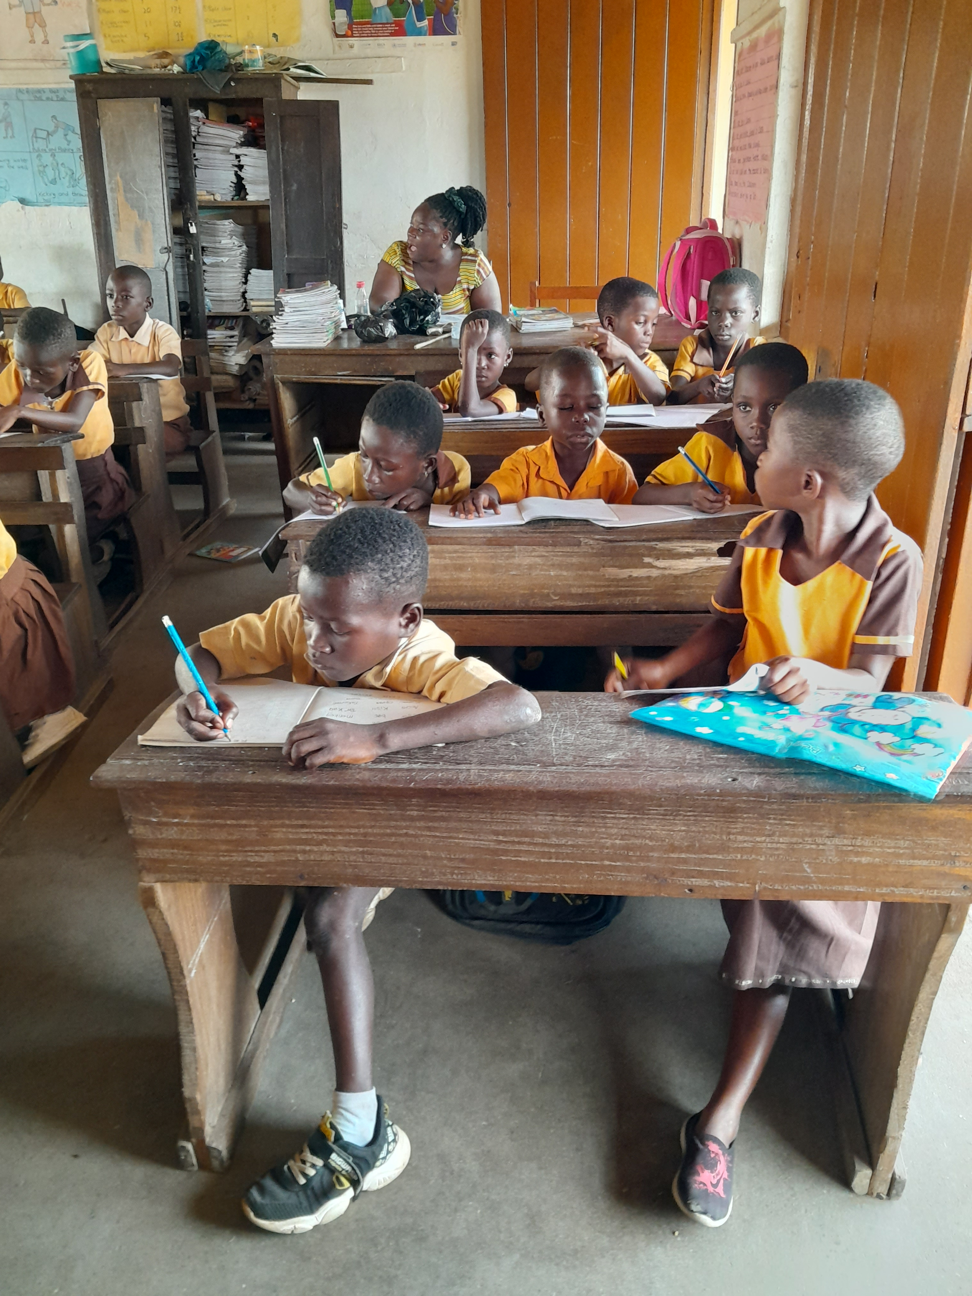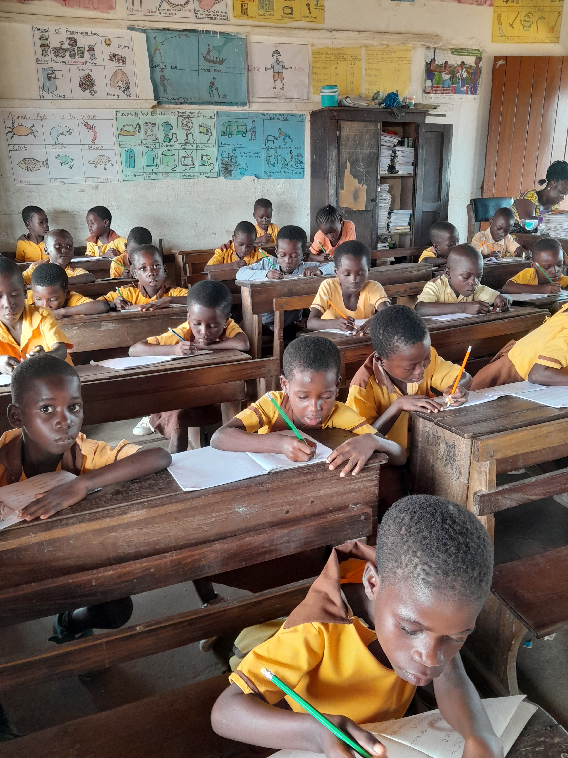 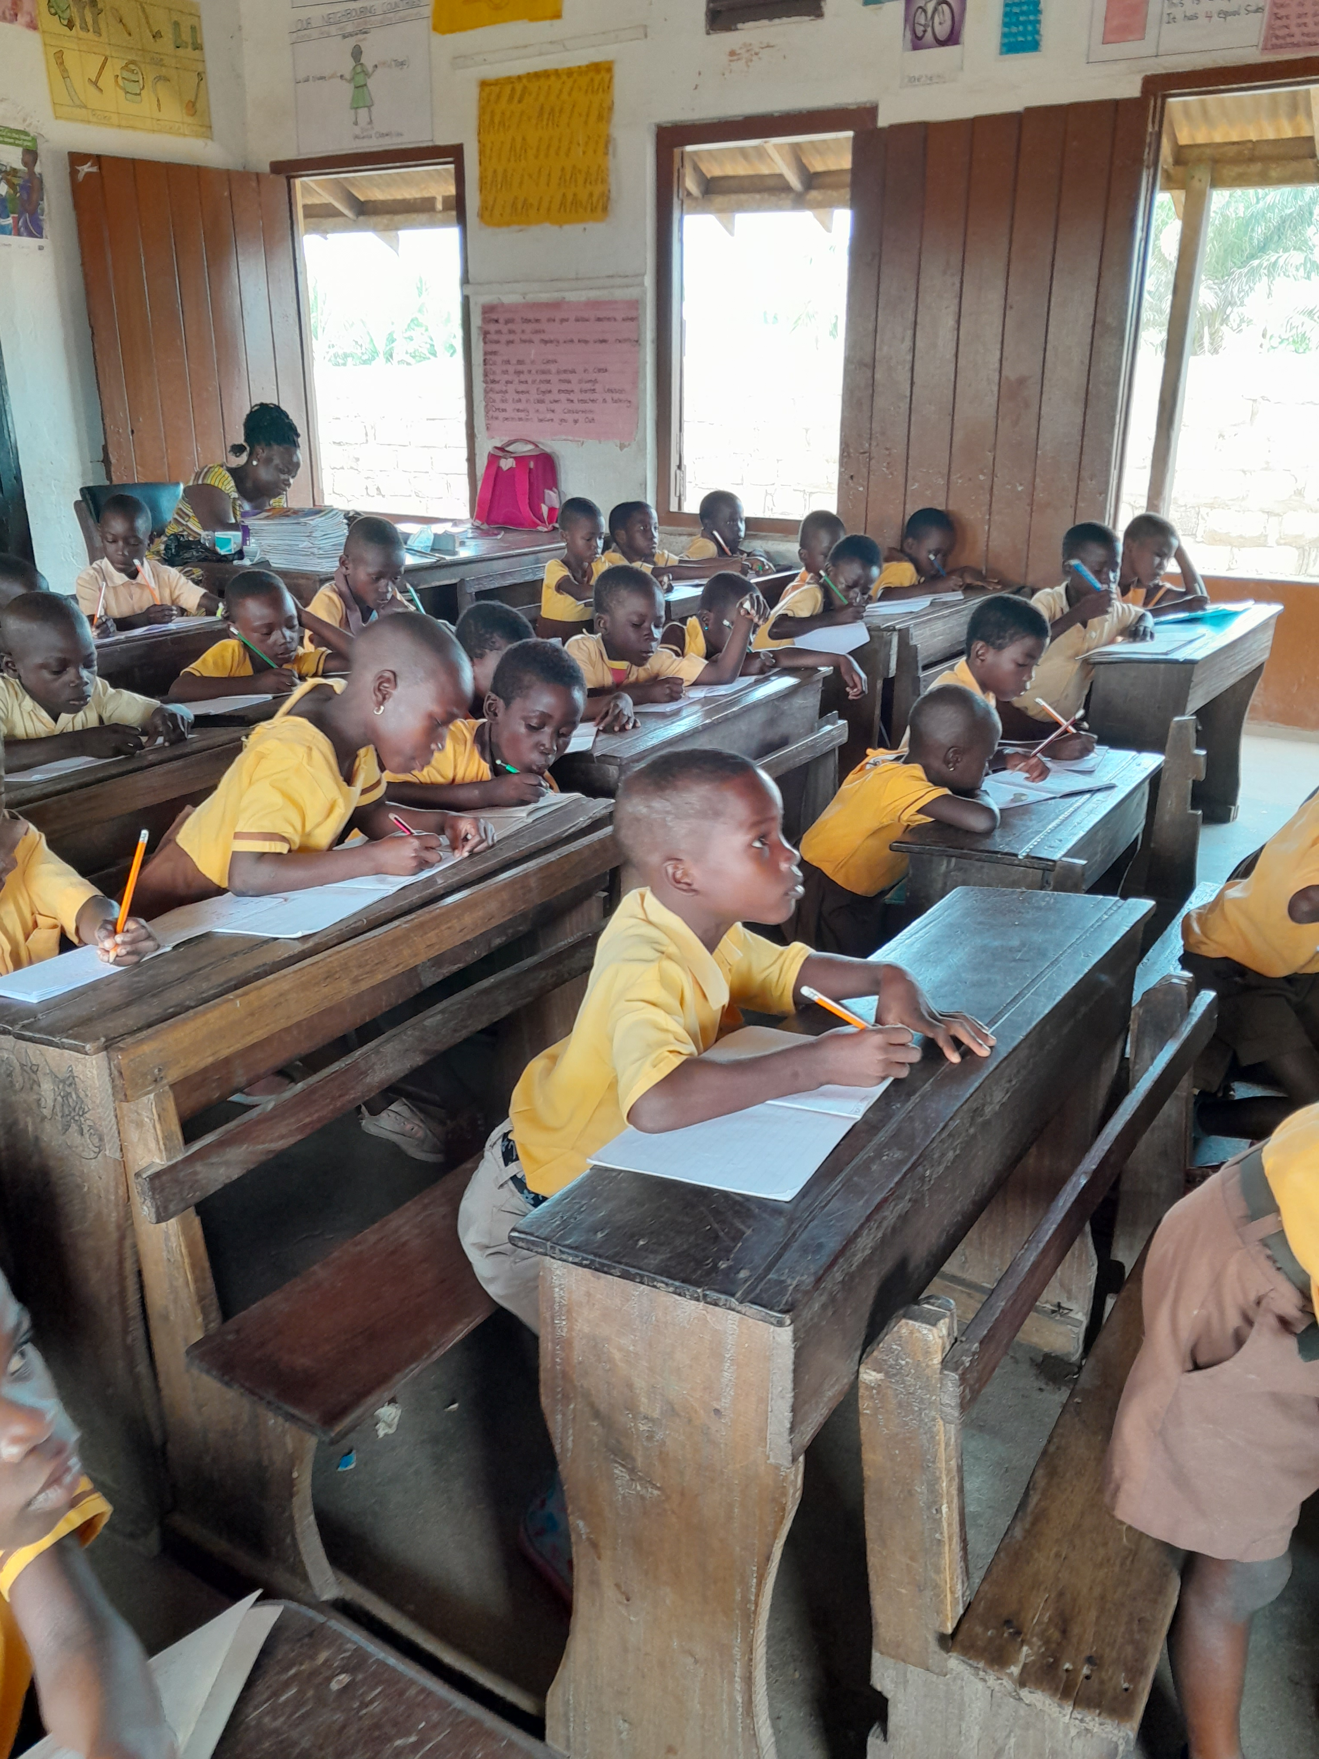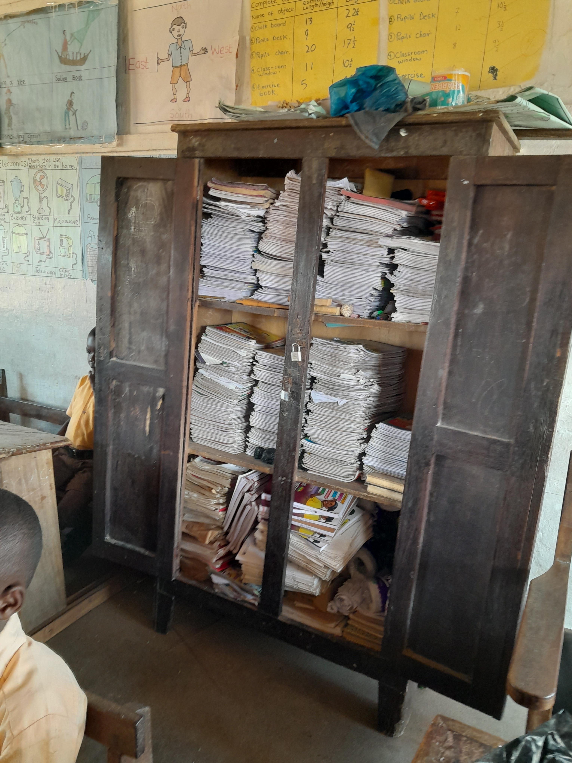 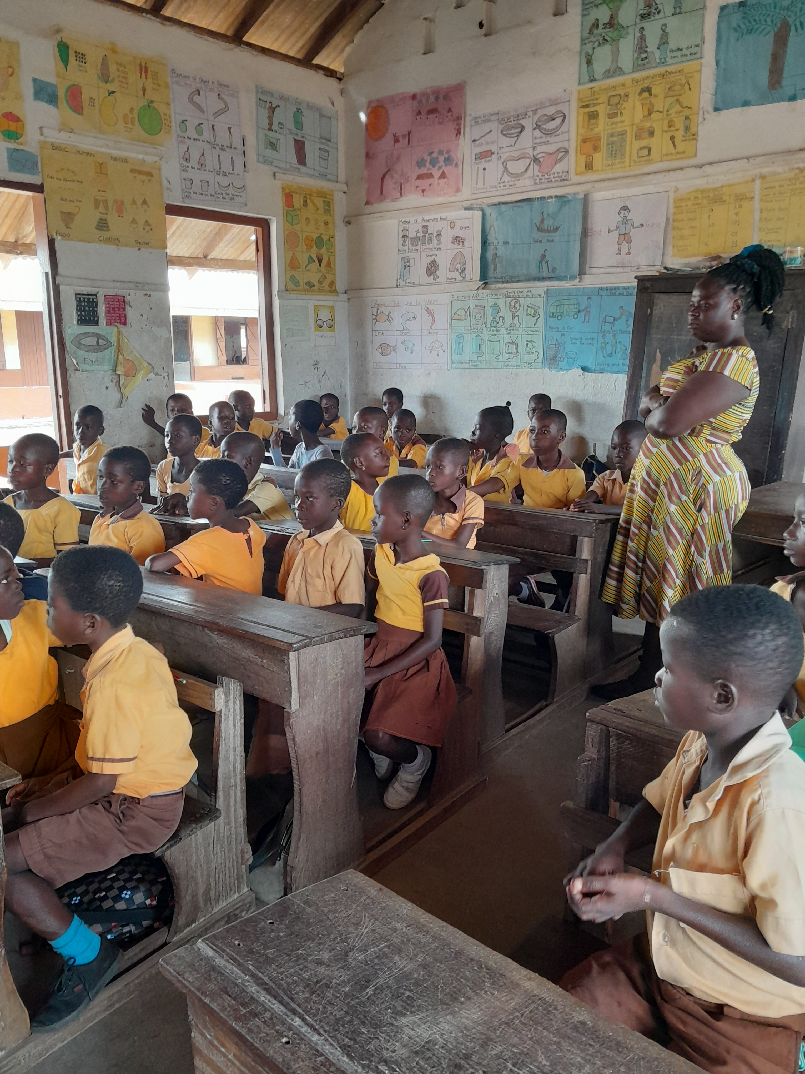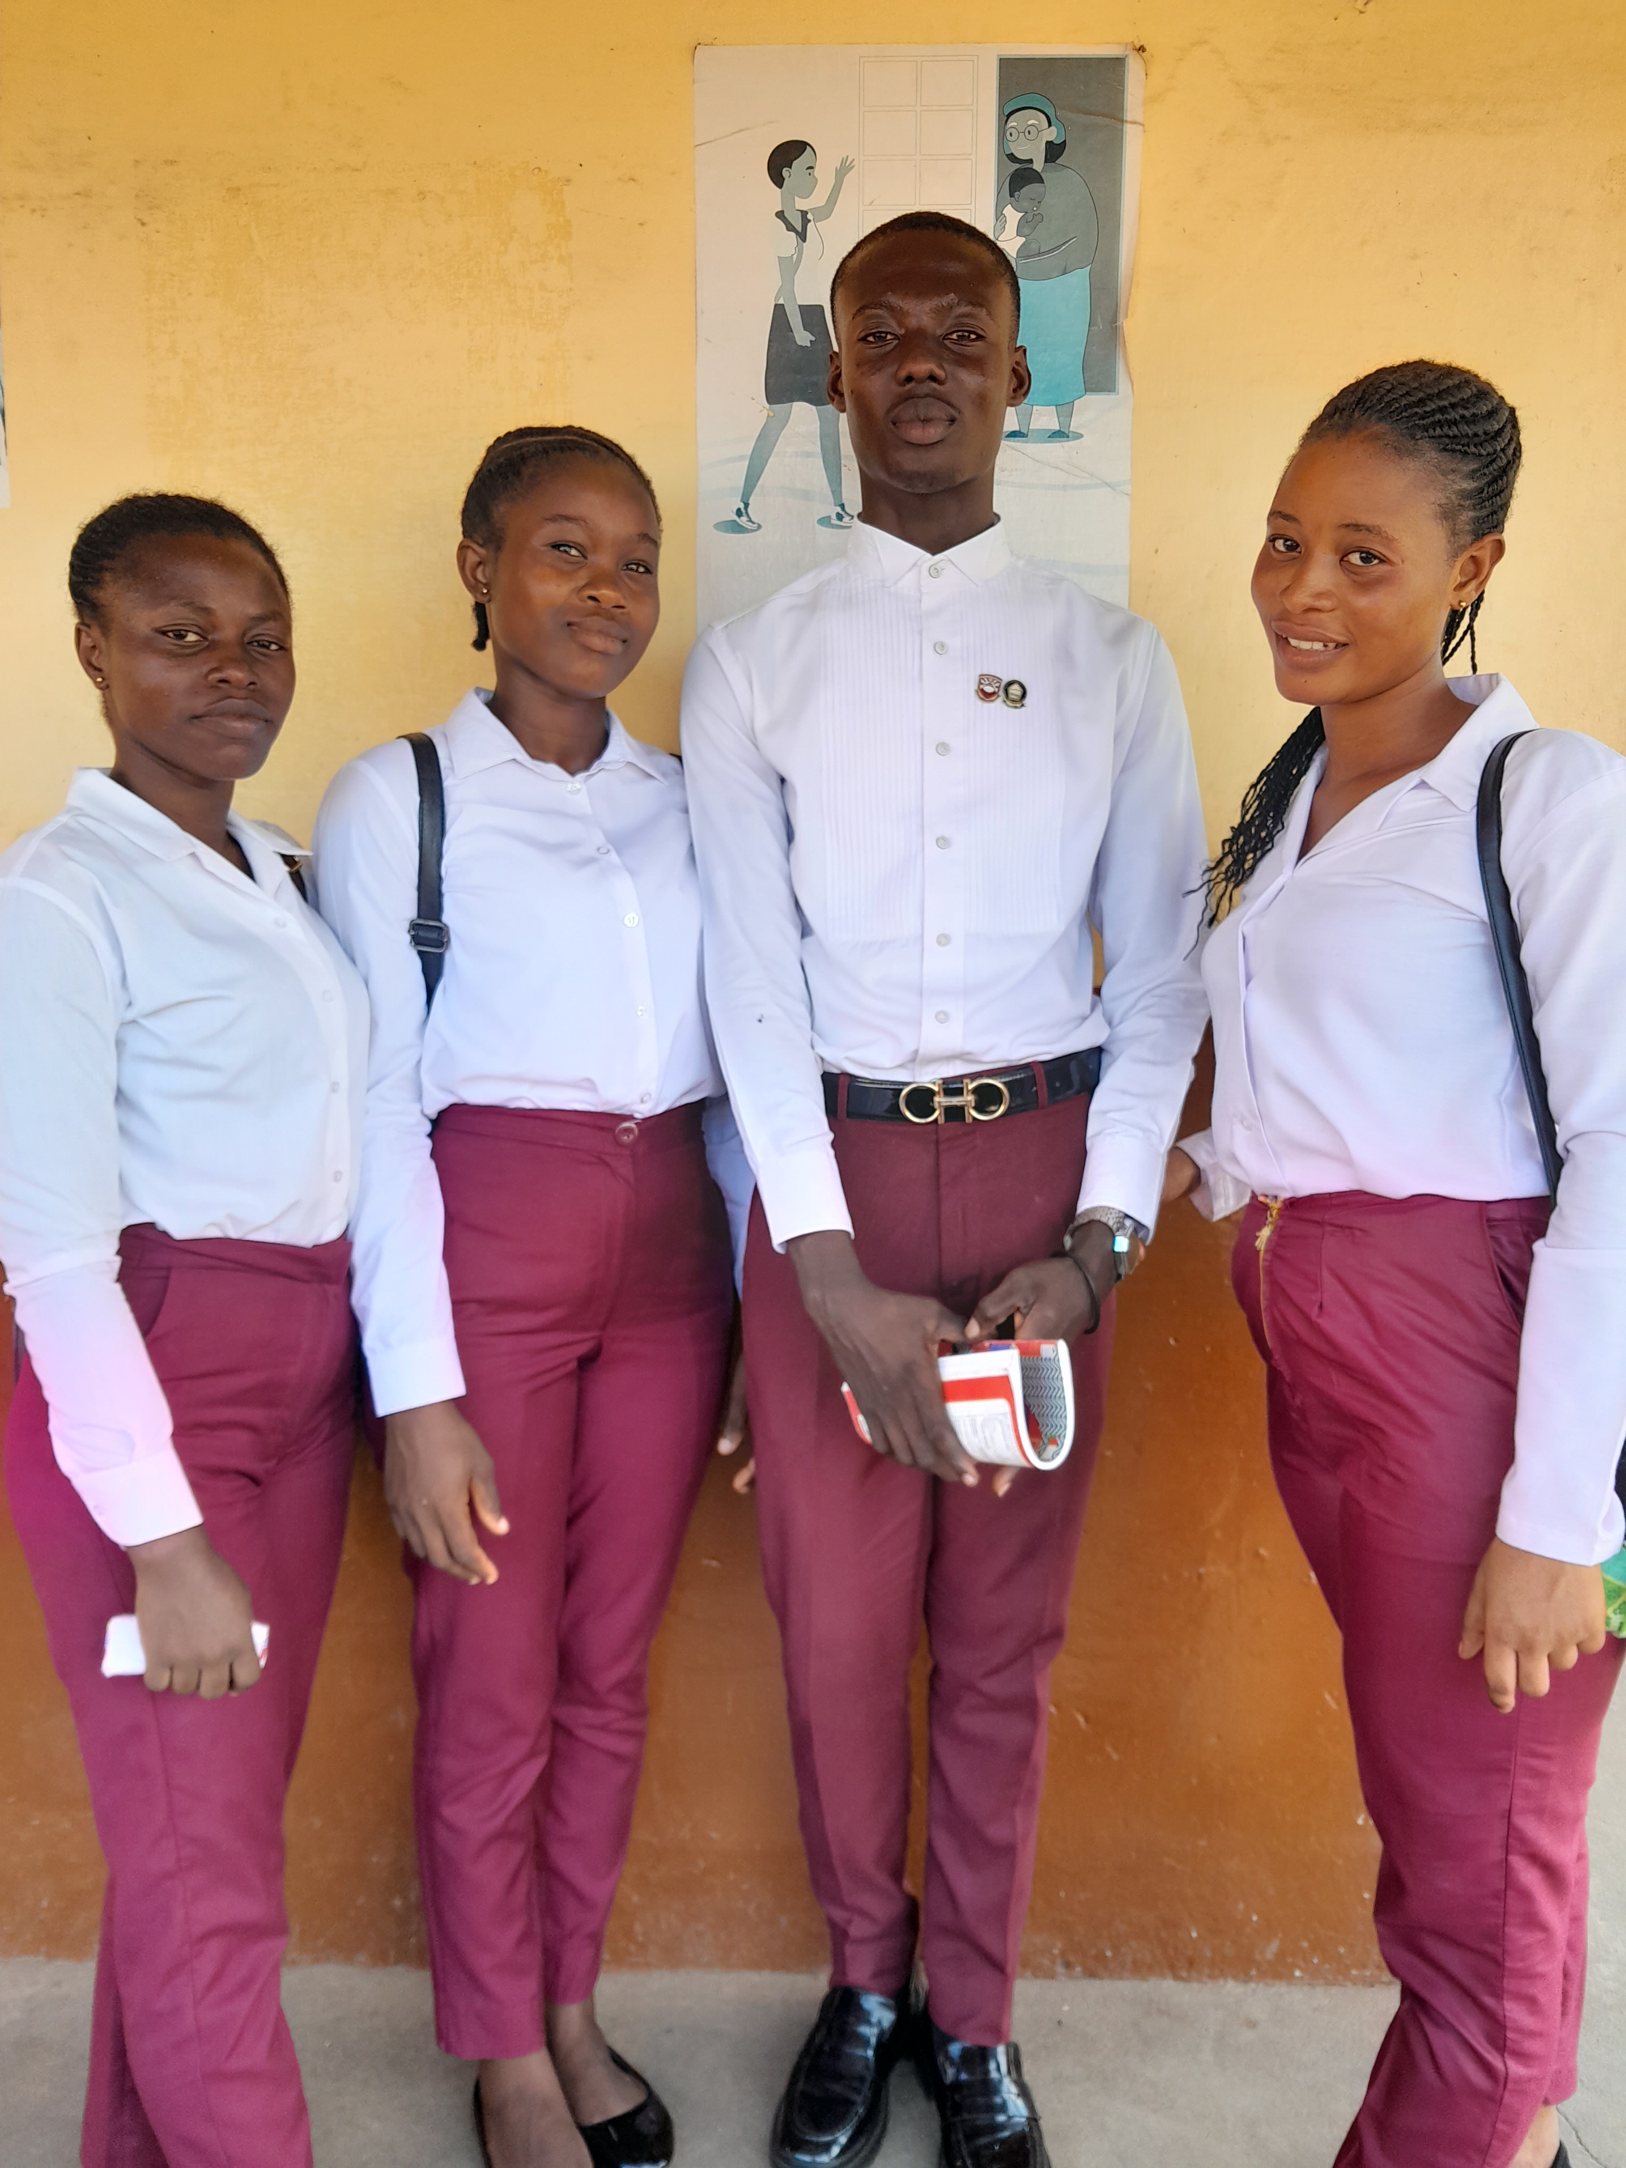 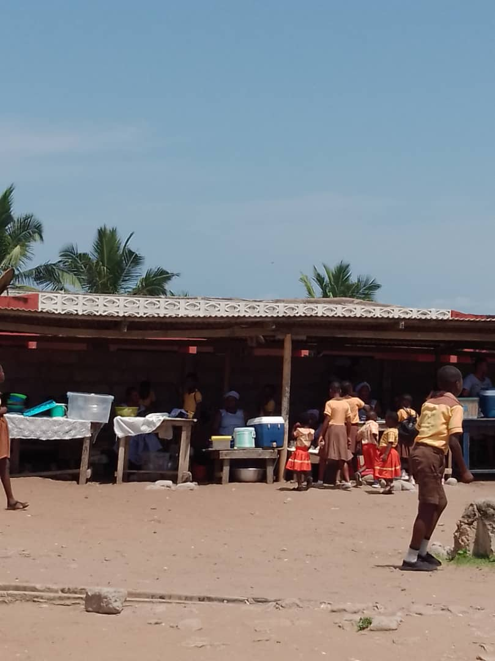

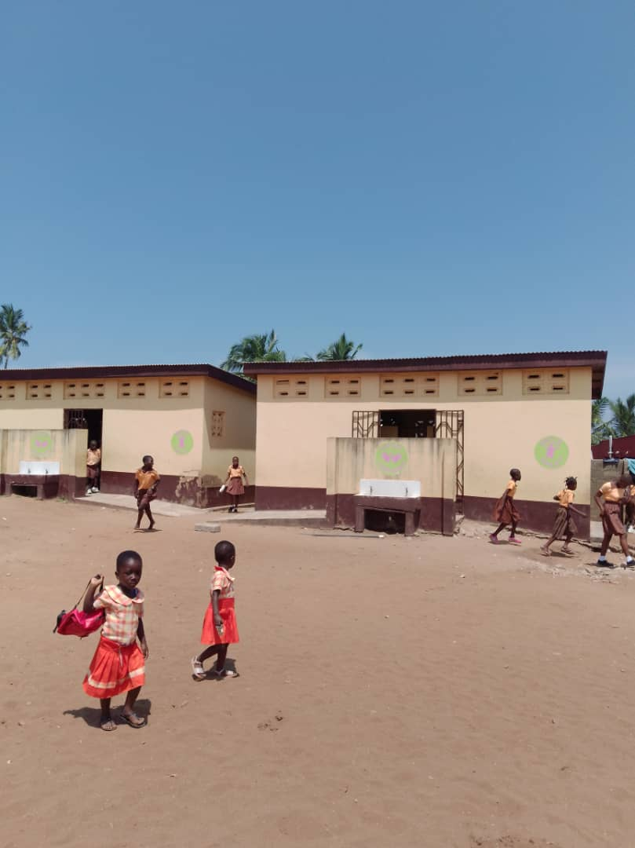**TOILET AND URINAL FACILITY**

**BRIEF HISTORY OF THE SCHOOL**

Komenda M/A Basic School was established in 1963, first headmaster was Mr. S.K. Yeboah. It started with eleven(11) learners until later it became big. Initially, it was a single sex school before it became a double school because of the population increment.

**MISSION OF THE SCHOOL**

To promote optimal learning to enable our learners to seek and use knowledge for personal growth, life skills development and service for humankind.

**VISION OF THE SCHOOL**

To provide quality education to all learners to help them fill into the society and the nation.

**MOTTO OF THE SCHOOL**

Knowledge, truth and service.

**STAKEHOLDERS COLLABORATION WITH SCHOOL**

There are stakeholders who are in collaboration with the school. The school has the following institutions like strong P.T.A body, a strong S.M.C body, the School Management Committee.

**OBSEVATION GUIDE FOR THE SCHOOL INFORMATION**

* Mentees Lesson Plan is available
* Gender Responsive is there
* They have Score Board
* Attendance Score Sheet is available
* Policy is available
* School Timetable

**HOW DAILY ROUTINES ARE MANAGED**

* Reporting time is 7:00-7:45am
* Registration is 7:45-8:00am
* All lessons start at 8:00am
* First break is 10:00-10:30am
* Second break is 12:30-1:10pm
* Lesson ends at 2:00pm
* An extended extra classes for 1hour

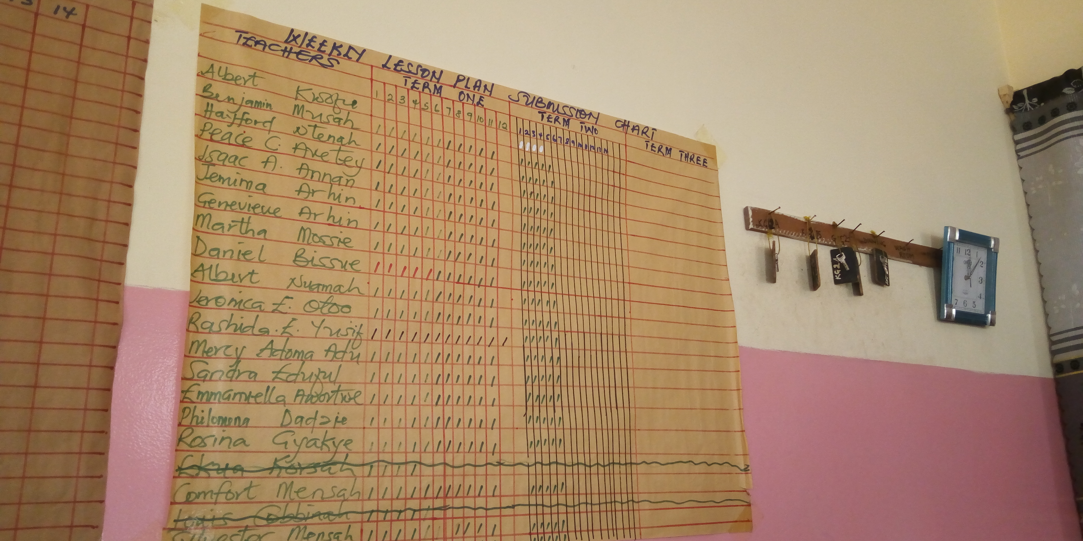

**SCHOOL RECORDS**

|  |  |  |
| --- | --- | --- |
| **RECORD** | **AVAILABILITY** | **PURPOSE** |
| Staff attendance | Yes | To check the attendance of teachers |
| Class register | Yes | To check student's attendance |
| Admission letter | Yes | To record the child's information as being enrolled in the school |
| Permission letter | Yes | To check the movement of the teacher's in and out of the school |
| Staff record book | Yes | To keep the details of the teacher's name, qualification and thier rank |
| Pupils examination board sheet | Yes | To records student's marks |
| Lesson note | Yes | To give guides to the teachers lesson |
| Student report card | Yes | To show the progress of the students after the academic year. |

**DAY TWO**

**KEY FEATURES OF THE BASIC SCHOOL CURRICULUM**

As part of the key features such as continuity and progression of the content in the Basic School Curriculum, my mentor also stated that, it is important to know the key features of the new curriculum and they are as follows;

* Provision for the acquisition of the 4Rs: Reading, writing, arithmetic and cReativity
* Making Ghana a Mathematics of Ghana
* Reintroduction the history of Ghana
* Emphasis on inclusion and diversity
* Provision for the development of the core competence (Foundation and Lifelong skill)
* Continuity and Progression of the Basic School Curriculum

Talking about the continuity and the progression of the school, my mentor explained that it is all about the content of the curriculum and this content needs to be well sequenced. She further added that, proper sequencing of the curriculum ensures that learning objectives are met. A proper sequence provides the learners with a pattern of relationship so that each activity has a definite purpose. The more meaningful of the content the easier it is to learn and consequently, the more effective the instruction. She did not just end there but also added that, proper sequencing also helps to avoid inconsistencies in the content of the instruction. When is carefully sequenced, duplication is far less likely. Indeed, the presence of duplication of the instruction often indicates that the program has been properly sequenced.

**COMPARISON OF THE SCOPE AND SEQUENCE OF SPECIFIC STRANDS IN THE BASIC SCHOOL CURRICULUM**

My mentor stated that, interrelated concept that refers to the overall organisation of the curriculum in order to ensure is coherence and continuity. Scope refers to the breadth and depth of the content and skills to be covered. Sequence also refers to how these skills and content are ordered and presented to learners over time. Taking English Language for instance, I was told by my mentor that, there are six(6) main strands and sub-strands in the English Language and the strand was: Oral Language which is the same as pre-reading, reading, phonics, dipthongs, grammar usage(words and phrases level). Under oral language there are also a number of sub-strands such as songs, rhythms, poems, storytelling, dramatization and role language is practiced by Basic 1-Basic 2 pupils.

**DAY THREE**

**CLASSROOM OBSERVATION**

**1. GOOD PRACTICES OF WHOLE CLASS AND SMALL GROUP INTERACTIONS**

This method involves taking turns to speak. I observed that students form circle of four and they were given a topic, and allow them a few minutes to organize thier thought about it. The discussion begins with each student having up to three minutes or choose a different length of uninterrupted time to speak. During this time no one else is allowed to say anything. After everyone has spoken once, open the floor within the sub-group for general discussion.

The teacher specify what students should only build on what someone else has said, not on thier own ideas; also, at this point they should not introduce new ideas.

Some shy students might feel uncomfortable to speak. Lessen thier fear by making the topic specific and relevant quotes to speak about. A variation to this method, which encourages students to listen more carefully to each other, involves requiring each person to begin by paragraphing the comments of the previous students.

**2. THE EFFECTIVENESS OF THE FEEDBACK DURING TEACHING AND LEARNING INTERACTIONS**

The included observations between teachers and students during teaching. Observation were conducted to document, the interaction between student and student, by observing the actions of teachers and reciprocal actions during the learning process. Observation were made by recording all interaction process using a video camera and audio recorder. Meanwhile face to face interview were conducted between student and teacher and our mentor. Interviews were carried out after the observation process was completed and when the interviews were in the relaxed state.

**3. CROSS-CUTTING ISSUES (INCLUSIVITY AND DIVERSITY) THAT EMERGED DURING THE TEACHING AND LEANING INTERACTIONS**

In an inclusive classroom, especially during the Mathematics lessons, relationship and interaction between mentor and student are crucial. This is especially the case in inclusive classes that require special needs. For example , in order for students who are slow learners to understand a subject matter, it requires continues repetition to ensure understanding so that learning can be observed. Teachers in inclusive classroom with student's special needs.

**CLASSROOM RULES AND REGULATIONS**

|  |  |  |  |
| --- | --- | --- | --- |
| **CLASSROOM AND OTHER SCHOOL RULES** | **WHY THESE RULES ARE IMPORTANT** | **HOW THESE RULES ARE ENFORCED** | **CONSEQUENCES IF THE RULE IS BROKEN** |
| Do not eat in the class | It keeps the classroom neat | It is enforced by the class reps | He/She will be sent to the guidance and counselling |
| Do not talk while teacher is in class | It provides a conducive environment for teaching and learning | It is enforced by the class teacher | Sent to guidance and counselling |
| Do not sleep in class | It provides active participation in class during lesson | It is enforced by the class teacher | Sent to guidance and counselling |
| Do not steal in class | It prevents student from stealing from thier friends | It is enforced by the class teacher | Sent to guidance and counselling |
| Do not fight in class | It prevents students from hurting themselves | It is enforced by the class teacher | Sent to guidance and counselling |

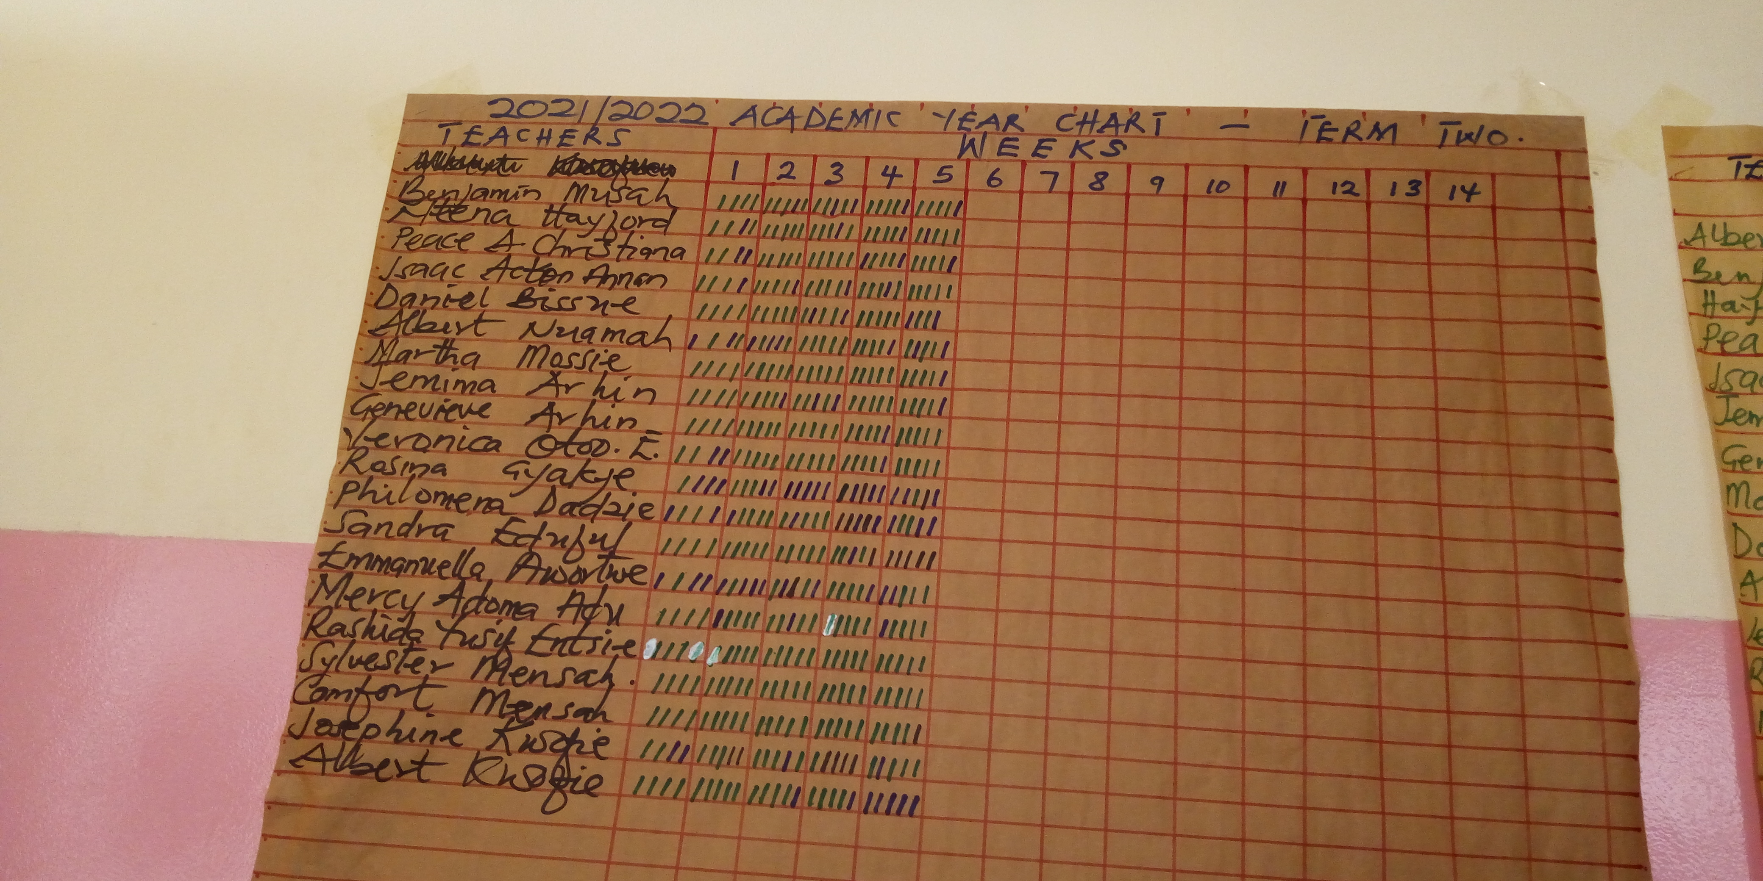 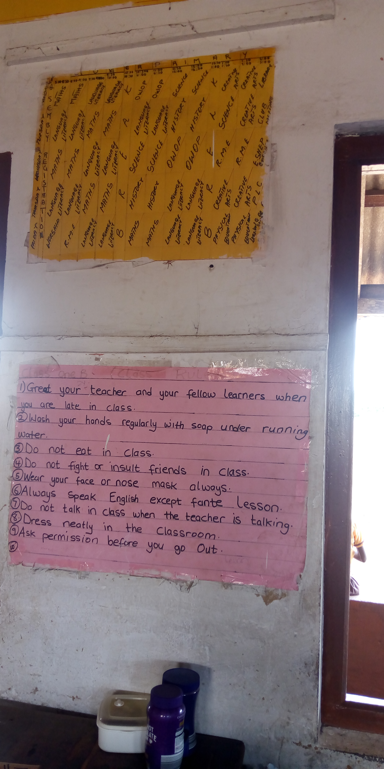 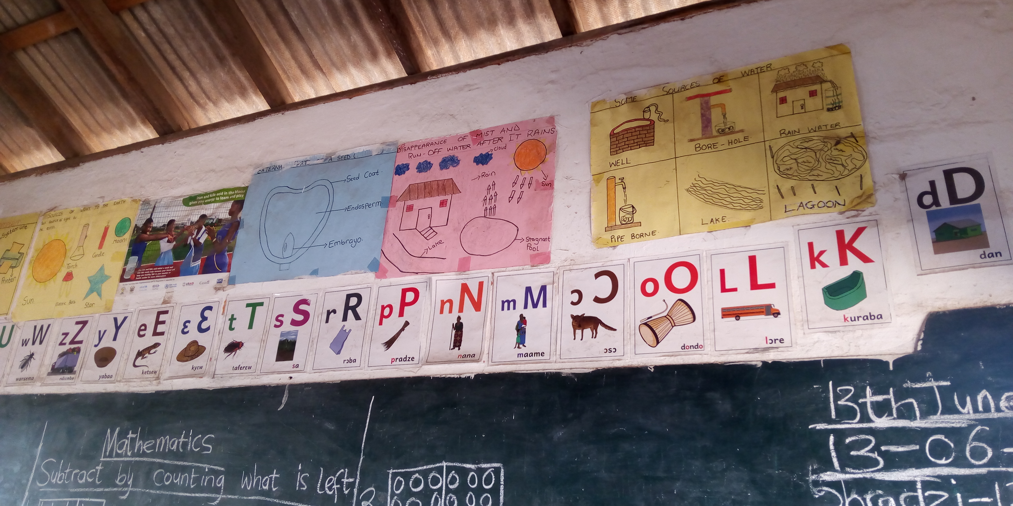

**DAY FOUR**

**EFFECTIVENESS OF CLASSROOM ENVIRONMENT**

This involves observing how effective the classroom is when lesson is in progress. The teacher encourage the students thinking by correcting them when there are wrong answers to a question which is being asked in the classroom. The learners engaged in discovery learning and they were expected to defend thier arguments. The teacher did this by asking them to give an example and explain so that the rest of the class will understand. Here are some activities students were asked to do during the lesson, they were asked to explore, explain, discover, describe, etc. The point they raised. T.L.M's which was based on the topic which was available for the student to use. The T.L.M was hanged on the board so that all the students will see it. The first 30minutes of the class time was for copying of notes.

**INTERVIEWING A GOOD TEACHER ABOUT CREATING A GOOD ENVIRONMENT**

By looking at thier various learning abilities, the teacher will decide how much time to provide learners to explore during lessons. Since the classroom is very dark, the arrangement help those with poor eye sight see very well. One approach I will adopt to help my students is by making TLM's available for them. When a students says he or she does not like a particular school subject, we advice and encourage them on that particular subject and make conjectures in my class. I do it by allowing those that are good in helping the weak ones. We also di remedial teaching for those with physical or learning difficulties.

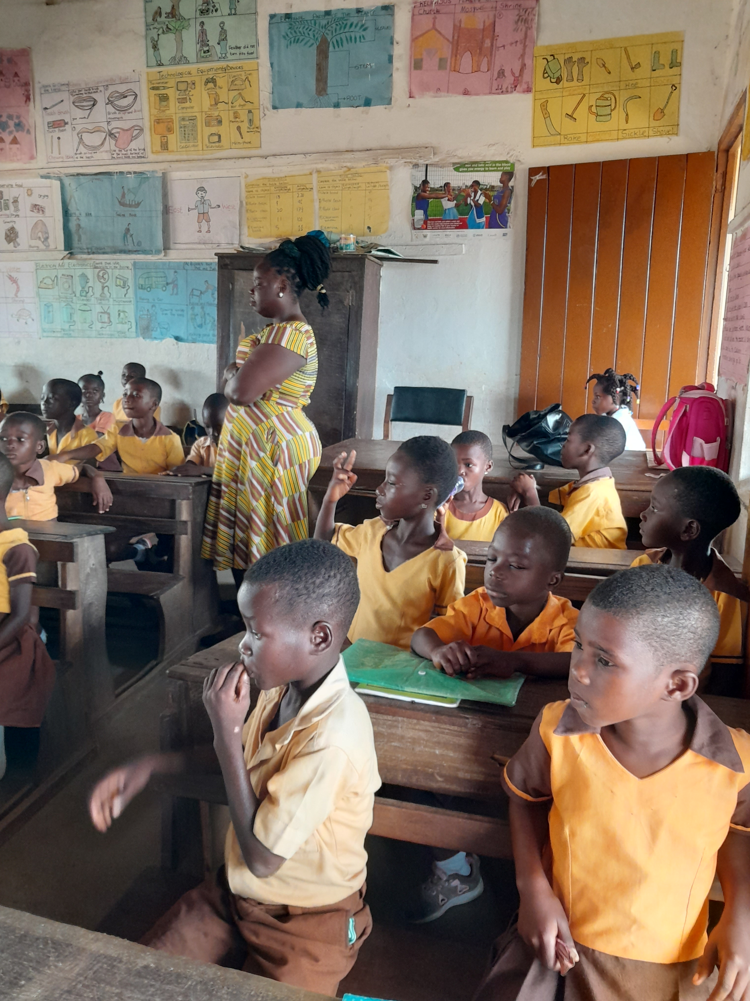 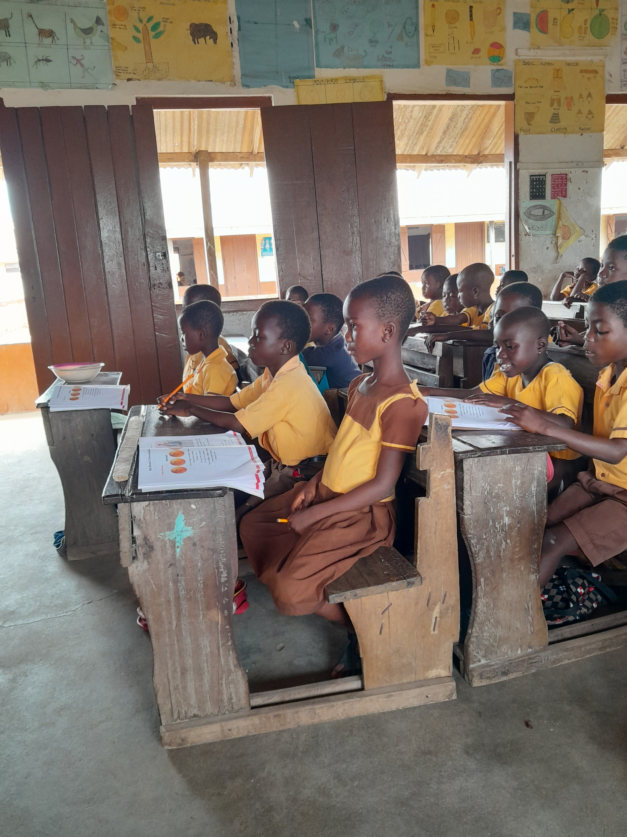

**DAY FIVE**

**CHILD STUDY**

|  |  |  |  |
| --- | --- | --- | --- |
| **NAME OF LEARNER** | **OCCUPATION OF PARENTS** | **LANGUAGE SPOKEN** | **WHERE PARENTS LIVE** |
| Naomi Efua Mensah | Fishing and Trading | Fante and English | Komenda |
| Micheal Cudjoe | Pastor and Trading | Fante and English | Komenda |

**FIRST STUDENT**

The name of the first student I interviewed was Naomi Efua Mensah. She is 6years of age and she lives at Komenda. She speaks both Fante and English. She is a good student and thinks she can do better. According to her, she is good at English and RME. She is good at sticking the things into the mind quaking. However, she has certain challenges in science, she is an average student when it comes to science. I saw that she is active in class and contribute in class a lot by answering and asking questions.

**SECOND STUDENT**

The second student I interviewed was a male called Cudjoe Michael and is 7years of age. He is from Kissi but lived at Komenda. The language he speaks is Fante and English. He is academically good in all subjects. He is very brilliant student in the school.

**OBSERVING STUDENT WITH SPECIAL NEEDS**

The student I interviewed do not have any learning disabilities or exceptionality. Butvhter are many learning disability in the classroom. Some students have understanding and learning disabilities. The teacher spends more time explaining things to them so that they will get more understanding. Some student also help those with the disability to catch up with them. The students with that disabilities usually don't complete the activities given in class because of thier low learning abilities.

**OBSEVATION ON HOW MY MENTOR DIVERSE LESSON TO SUPPORT STUDENTS**

I observed that, after the teacher had introduced the lesson, She wrote the topic of the day on the board. Again, I observed that the teacher communicate with the students by using Fante and English Language. The students also use Fate and English to communicate with the teacher too. I observed that the teacher involve the student in the lesson, the teacher did that by brainstorming students and sometimes used questions which demand an answer. I observed that the teacher uses a lot of strategies to keep them focused on track. She gave task to the individual student to do in other to keep them focus on the lesson. I also observed there are materials that help the teacher to deliver the lesson successfully. Some of the materials are the teacher's lesson notebook and a personal laptop.

**TEACHER'S RELATIONSHIP WITH OTHERS**

|  |  |
| --- | --- |
| **MENTORS RELATIONSHIP** | **TEACHERS RELATIONSHIP TOWARDS OTHERS** |
| Students | She gives students support and encouragement according to thier individual needs |
| Other teachers | She plans together with other teachers |
| Head teacher | He cooperates results, accepts new roles and responsibilities assigned to her. |

**DAY SIX**

**TEACHING PHILOSOPHY AND BUILDING PORTFOLIO**

**MY TEACHING PHILOSOPHY**

As a look back at my school age days and reflect on the attitude and the values of my teachers, I could see the not so good and the bad and the ugly. Lesson from this experience, reinforce by a combination of formal training in an effective teaching practices, this experience has shaped my teaching philosophy.

So therefore, my inspiration as a teacher is to be an influential who inspires my students to be the best of thier self. I want my students to feel and be able to share anything with me whether it is from home or at school, I will be able to give them good advice. During my own years as student at high school, there was just a few teachers whom I felt completely at ease with, and was able to share what was in my heart with them knowing as they would not judge my condition and would provide me with advice that was life changing. That feeling of being able to have adult who spoke to me an an equal is one that I wish to invoke in my students when they ate with me.

My goal for my students is for them to be able to gain better understanding of themselves as that will boost thier confidence and self-image leading them to be confident individual in this real world, I want my students to be able to gain full mastery over the topics I teach and discuss with them so that they will be able to teach others at different levels. I want my students to have quick critical thinking skills where they will be able to tackle any problems thrown thier way with ease.

**COLLECTION OF ARTEFACTS, INCLUDING THE USE OF ICT TOOLS FOR BUILDING PERSONAL PORTFOLIO**

* A list of course taught
* Syllabus
* Assignment
* Description of class activities
* Student evaluation
* Sample student work
* List of faculty development activities
* Presentation on teaching

**CONCLUSION**

Komenda M/A Basic School is endowed with good and quality teachers and also have Veronica tanks filled with water and a soap beside it, so that one can wash his or her hands anytime he or she visits the toilets.

Those who use thier hands to do other unhealthy activities also use the soap and water to wash thier hands to ensure effective personal hygiene and improve the student's healthy living in and outside the school.

**SEMESTER BREAK STUDENT REFLECTIVE JOURNAL**

**STS IN SEMESTER BREAK**

**OCTOBER, 2022**

**STUDENT NAME: ABIGAIL AWUAH**

**REFERENCE NUMBER: 2121487**

**PROGRAMME: B.ED EARLY GRADE DEVELOPMENT**

**SCHOOL VISITED: NKWANTAKESEDO METHODIST BASIC SCHOOL**

**LEVEL OBSERVED: BASIC 2**

**HEAD TEACHER NAME: MR. BENJAMIN KOFI DJAN**

**NAME OF MENTOR: MADAM LUCY**

**COURSE TITLE: FIELD EXPERIENCE**

**DISTRICT: SHAMA DISTRICT, WESTERN REGION**

**CIRCUIT: NKWANTAKESEDO**

**STS SUPERVISOR: MR. ERIC SEKYI**

**TEACHING PHILOSOPHY STATEMENT**

Teaching is an act of imparting knowledge from more experienced person to less experience person. Philosophy is a view or outlook regarding fundamental principles underlining some domain. Teaching philosophy is a self-reflective statement of your believes about teaching and learning.

As an early grade teacher, I believe that, family relationship are essential component of our education system.

I hope that through my teaching I can provide student with the opportunity to learn life skills, exercise creativity and think about the world around them.

Regardless to discipline, I hope to create a classroom environment where student will feel safe, accepted, supported and encourage student irrespective of thier backgrounds, gender, religion, ethnicity, physical and mental ability.

I intend to make my classroom a place where all student is accepted and valued for who they are and given a safe space to make connection, grow and to build confidence.

As an early grade teacher, I hope to impact student with the pertinent skills that will help them succeed in life. As a teacher, I hope to equip them the skills and the knowledge to manage thier life and thier family living. Am not only to teach them about the subject matter but the relevance to thier present life's that can be of constant use as they grow. I will also allow student to acquire the necessary skills, for instance, decision making, social and communication skills which are deemed as critical qualities for occupational success. All these are polished through the execution of course work where the teacher takes the role as facilitator to guide the students in exploiting the project.

**WEEK ONE**

**FAMILIARIZATION WITH SCHOOL ENVIRONMENT AND RECORDS**

On Monday, 10th October, 2022, I arrived at Nkwantakesedo Methodist Basic School for observation. The school is located at Shama Nkwanta in the Western Region. When I entered the school, the compound was clean and tidy. There was no litters around, dustbins are put at various points to prevents littering around. I arrived at 7:30am. I was introduced by the headmaster, staff and the student body and my purpose of coming.

**HISTORY OF THE SCHOOL**

The idea for the establishment of the school came about during a meeting by the leaders of the Methodist Church of Ghana. Nkwantakesedo in mid-August, 1983. At the leaders meeting, they agreed to the establishment of the school for the community. The leaders forwarded the idea to superintendent minister, late Rev. John Kwesi Banson of Shama, then local manager for Methodist Schools, who endorsed the establishment of the school.

Mr. Francis S. K Panyin, Mr. Moses F. Ekrakow, late Mr. John H. Panyin and Mr. Hasford J. Aborwofie are members of the church who served as teachers to the pupils. The local church, Nkwantakesedo agreed to put up a structure at where the church of Pentecost Chapel is currently situated to serve as classrooms for the pupils. Late Egya Kobina Kyere provided the blocks and wooden boards which served as chairs for pupils and the local church also helped with the chalkboards. The school started with eighteen(18) pupils, ten(10)girls and eight(8)boys.

Two years later, the School was relocated to the Chapel of the Methodist Church of Ghana, Nkwantakesedo which shared the same compound with Mr. Handforth J. Aborwofie and Mr. Samuel K. Eshun. Madam Alberta Wilson, then Headteacher of Shama Methodist KG helped with two(2) volunteers namely; Madam Fancy Wilson and the late Madam Elizabeth Panyin, who served as permanent teachers to the school. Through the help of the 1st assembly member of Shama Electoral Area, Mr. Agyenim Boateng, the community gained help from the Seventh-day Adventist Church, with bags of cement which was used in laying blocks for the school. The school was relocated to its current environment with the help of the committee members of the community who helped secure plots of land from the NSONA EBUSUA of Nkwantakesedo.

In 1993, the School was handed over to the government which saw the introduction of the first Headteacher, Madam Francisca H. Arthur. The classes were from basic 1 to 3. Unfortunately, the school was closed down in 1994 due to infrastructural challenges. Due to the immense effort by Miss Susanna Eshun, then Regional Manager of Methodist Unit, the School came into existence in 1994.

In 2002, Madam Francisca Arthur was succeeded by Mrs. Beatrice E. Bartels. Due to the departure of Mrs. Beatrice Bartels in 2008. Mr. Anthony Kwo, then Assistance Headteacher acted as the Headteacher until the arrival of Madam Mercy Rockson in 2008 as the substantive Headteacher of the school.

In 2011, the School became a basic with the establishment of JHS. Mr. Worlanyo Adatsi and Madam Nancy Creteil were the pioneer teachers for the JHS in 2014, the first batch of students partook in the BECE with seven(7) boys and five(5)girls. The District awarded the school as the second best performed public school and MISS Josephine Addae was also awarded the best performed female student in the 2017 BECE. Miss Paulina Koomson was in 2019, awarded the best performed female student in the BECE.

Mr. Ebenezer Kofi Djan succeeded Madam Mercy Rockson in January, 2021 as the new Headteacher of the school.

**SCHOOL PROFILE**

Nkwantakesedo Methodist Basic School is managed by the Municipal Assembly. The school is situated at Nkwantakesedo a few kilometers drive from Shama. The school nine(9) teaching and learning classrooms with o e headmaster's office and a staff common room. The school also have library, canteen, football court and volleyball Court. The school have toilet and urinal facilities for both male and female students to ensure proper sanitation.

**MISSION OF THE SCHOOL**

The school exist to assist pupil to develop thier full potentials in all aspects of life by entering a safe and conductive learners, centered environment with the support of the home and the community.

**VISION OF THE SCHOOL**

To train pupil to become morally, spiritually, physical sound and useful to the nation.

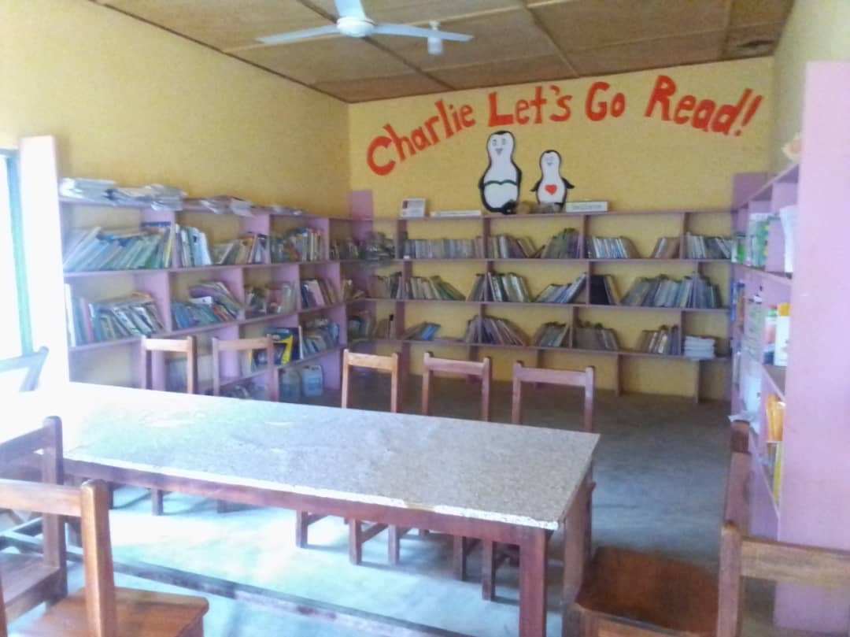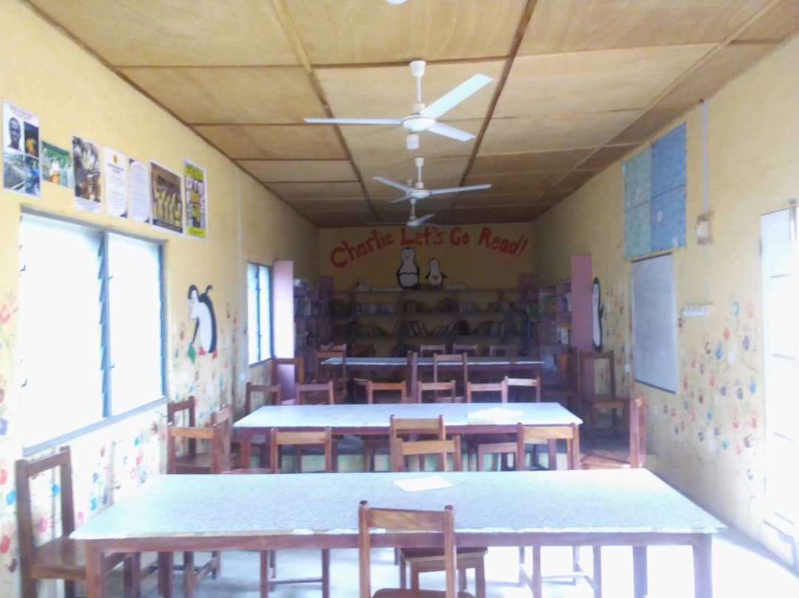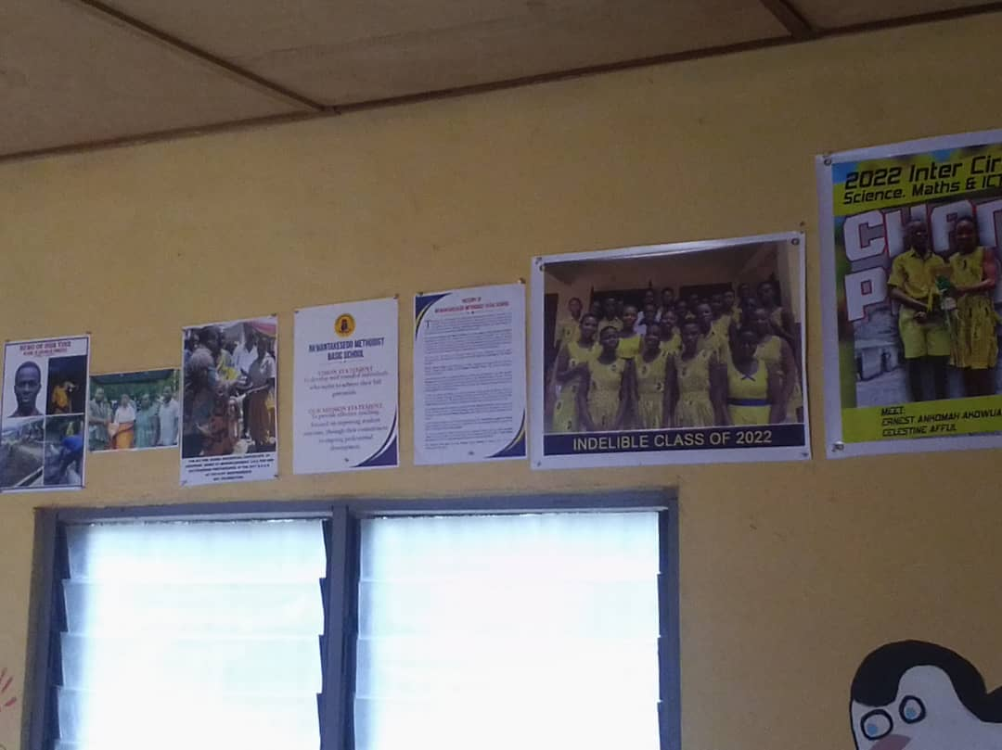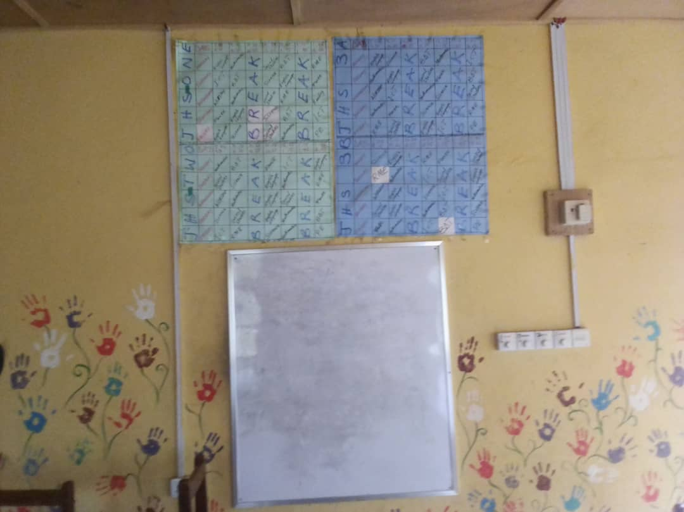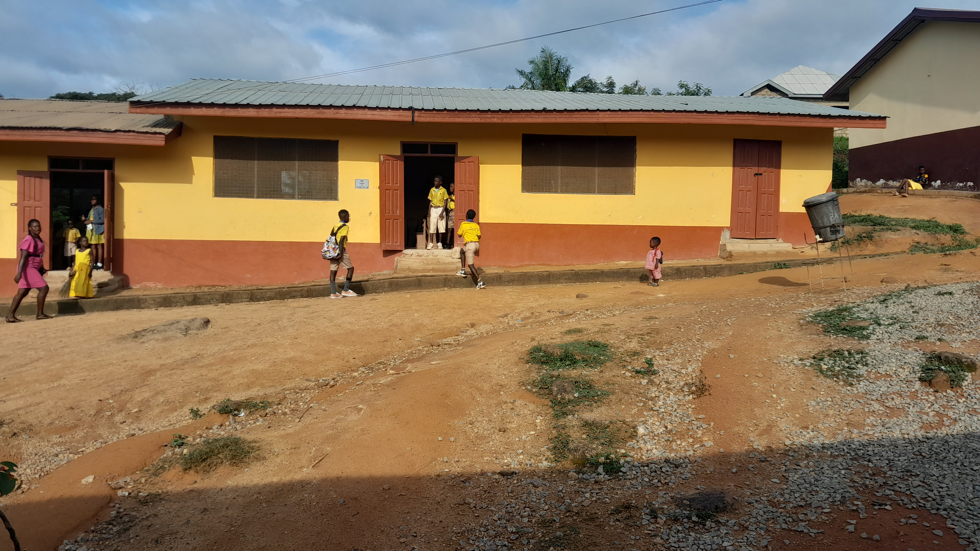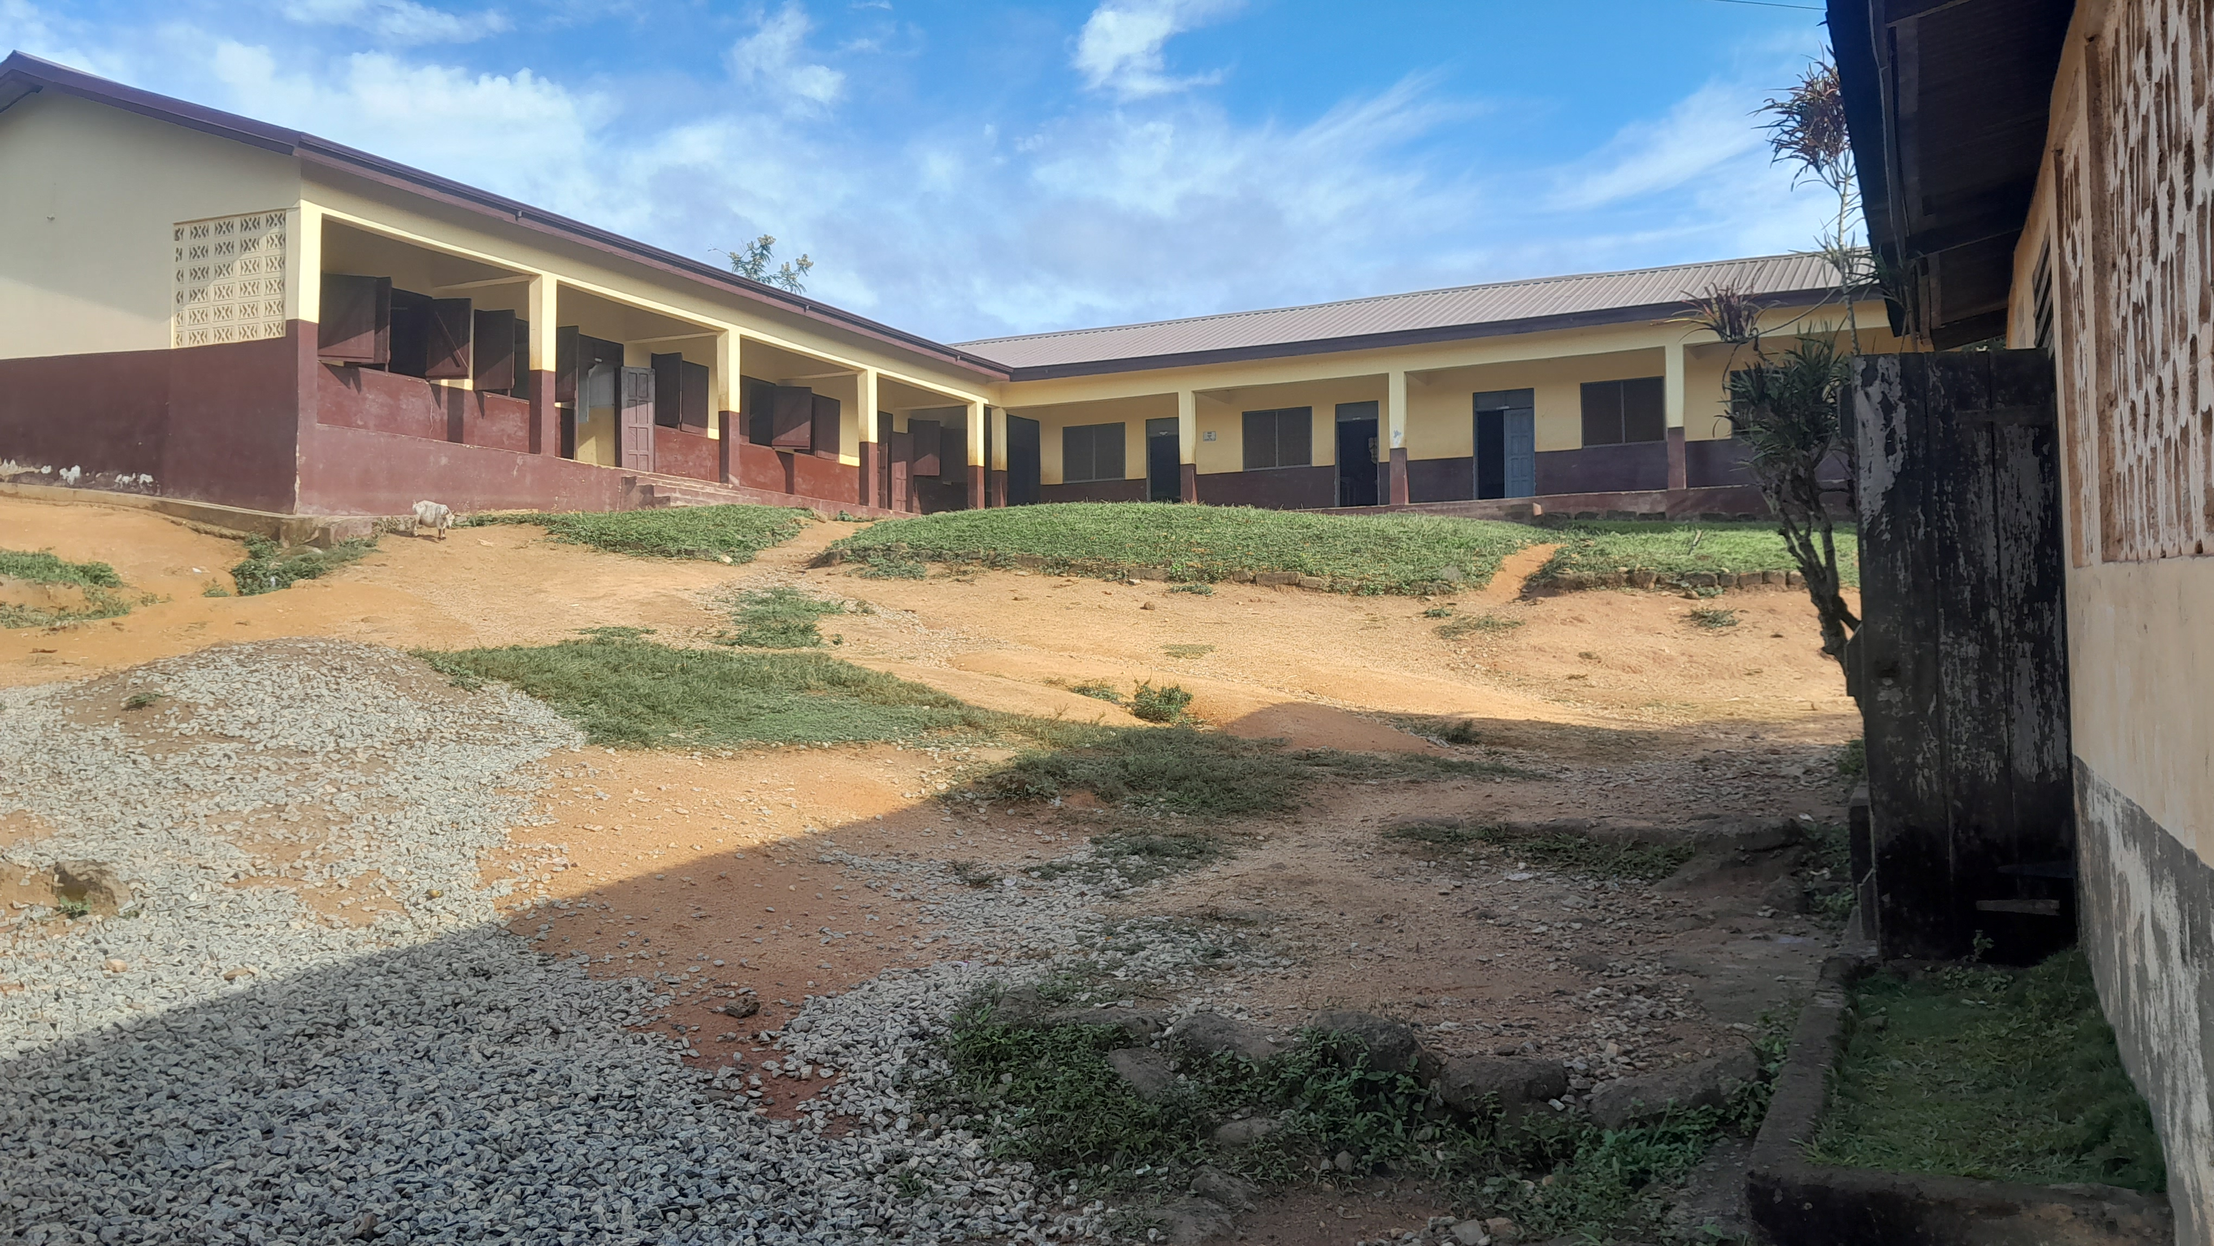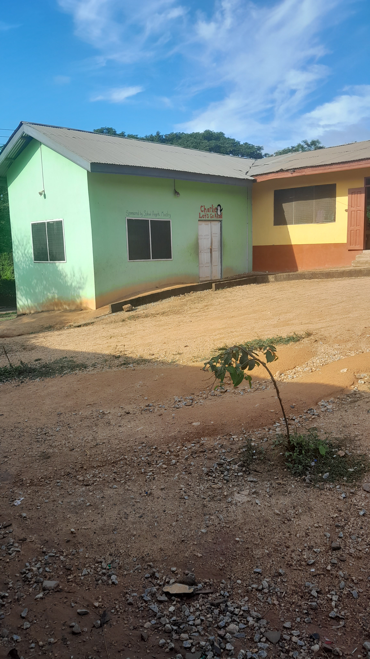SCHOOL LIBRARY BLOCK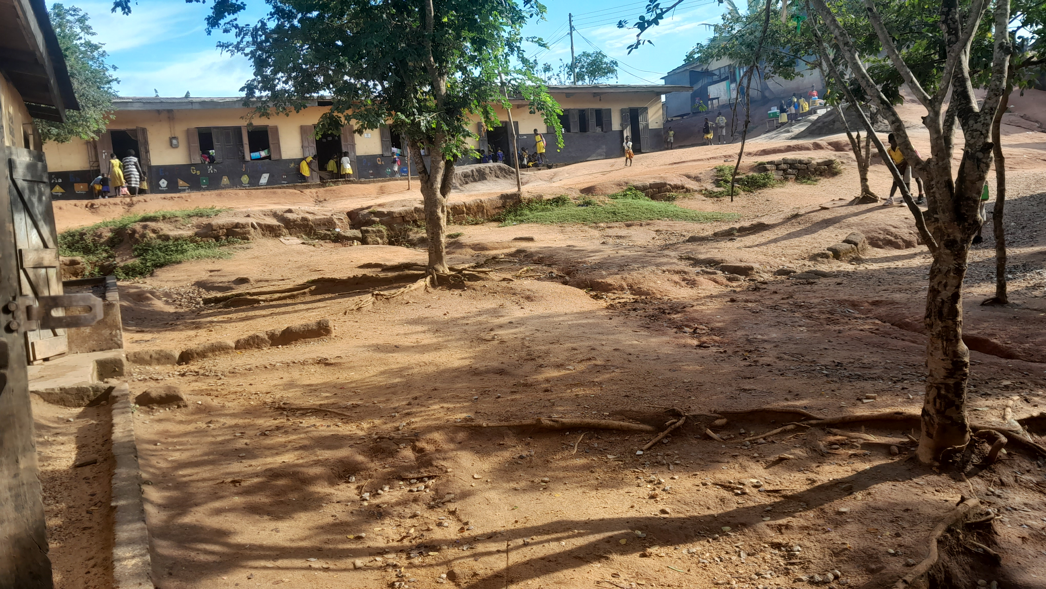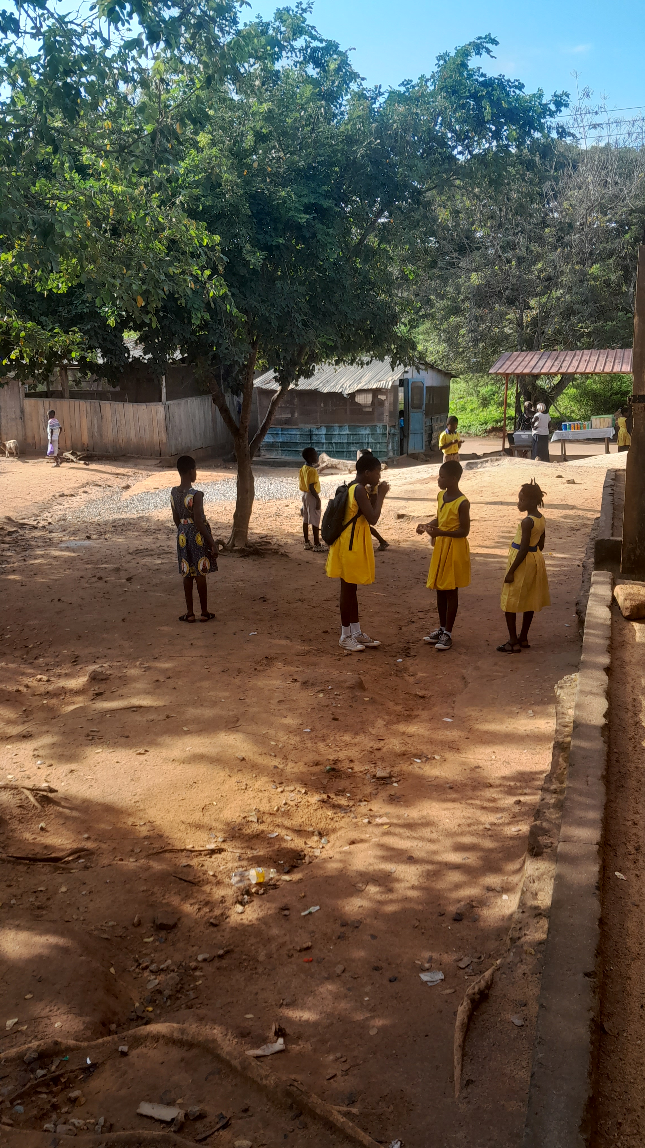**PLAY GROUND**

**SCHOOL RECORDS**

I observed that certain items were available. Some of the available items include Teachers and Students Attendace Register, School Rules and Regulations which are documented and School Timetable. The Attendance Rwgister held to check the behaviours and activities of teachers and students. The availability of the timetable also help to organize all the learning activities in an orderly form.

**OBSERVATION GUIDE FOR THE SCHOOL ENVIRONMENT**

|  |  |
| --- | --- |
| **ITEMS** | **AVAILABLE** |
| Attendace Register | Yes |
| Lesson Plan note | Yes |
| Teacher's Manual | Yes |
| Pupils Textbook | Yes |
| School Timetable | Yes |

**HOW DAILY ROUTINES ARE MANAGED**

|  |  |
| --- | --- |
| **ROUTINES** | **TIME** |
| Reporting Time | 6:30-7:30am |
| Registration | 7:30-7:45am |
| Silent Hour | 7:45-8:00am |
| Start Lesson | 8:00-10:30am |
| First Break | 10:30-11:00am |
| Lesson Continues | 11:00-12:30pm |
| Second Break | 12:30-1:00pm |
| Lesson Ends | 2:00pm |

An extended extra classes for 1hour.

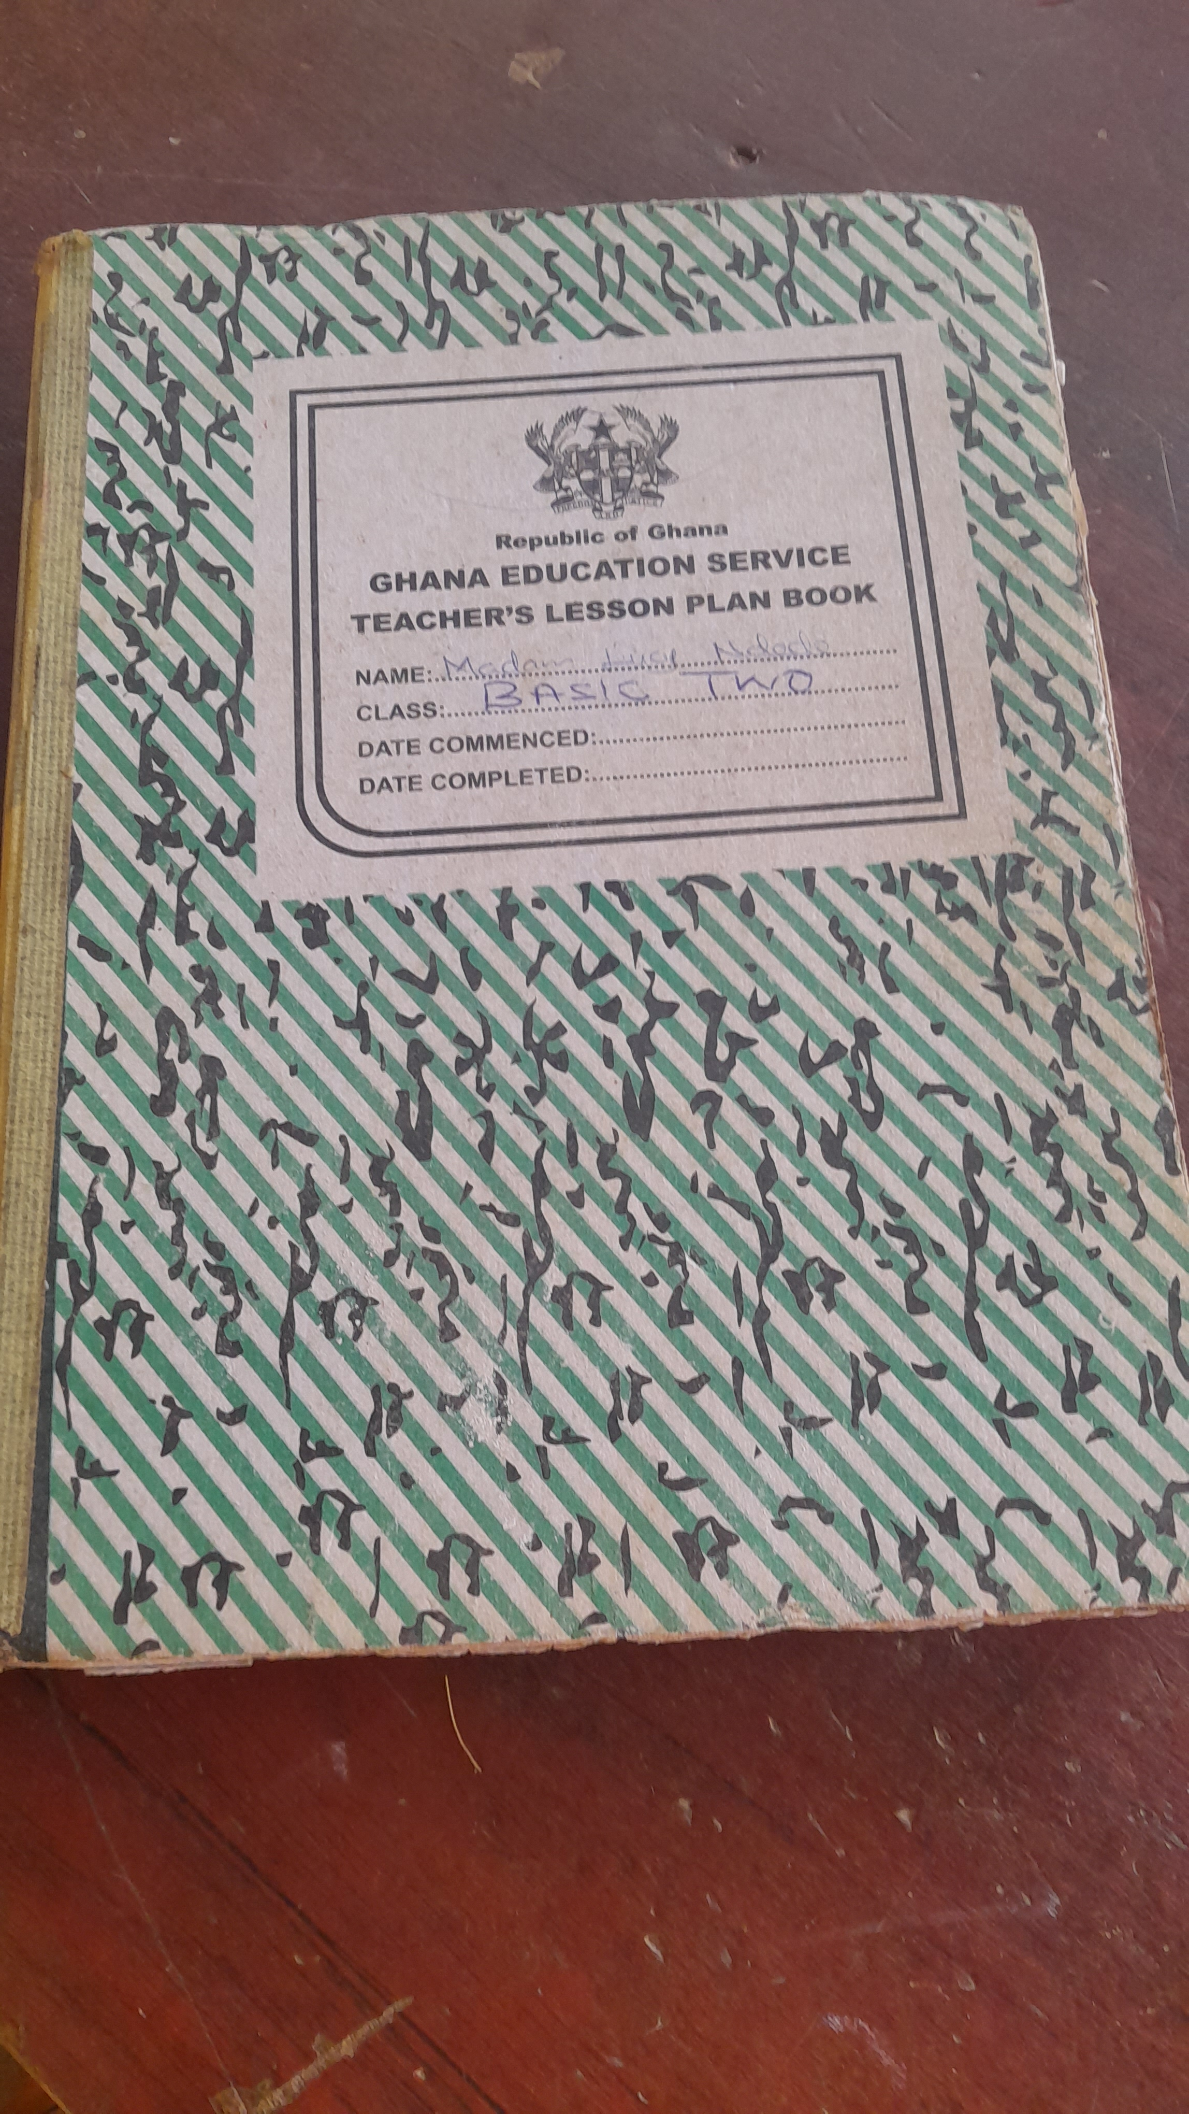 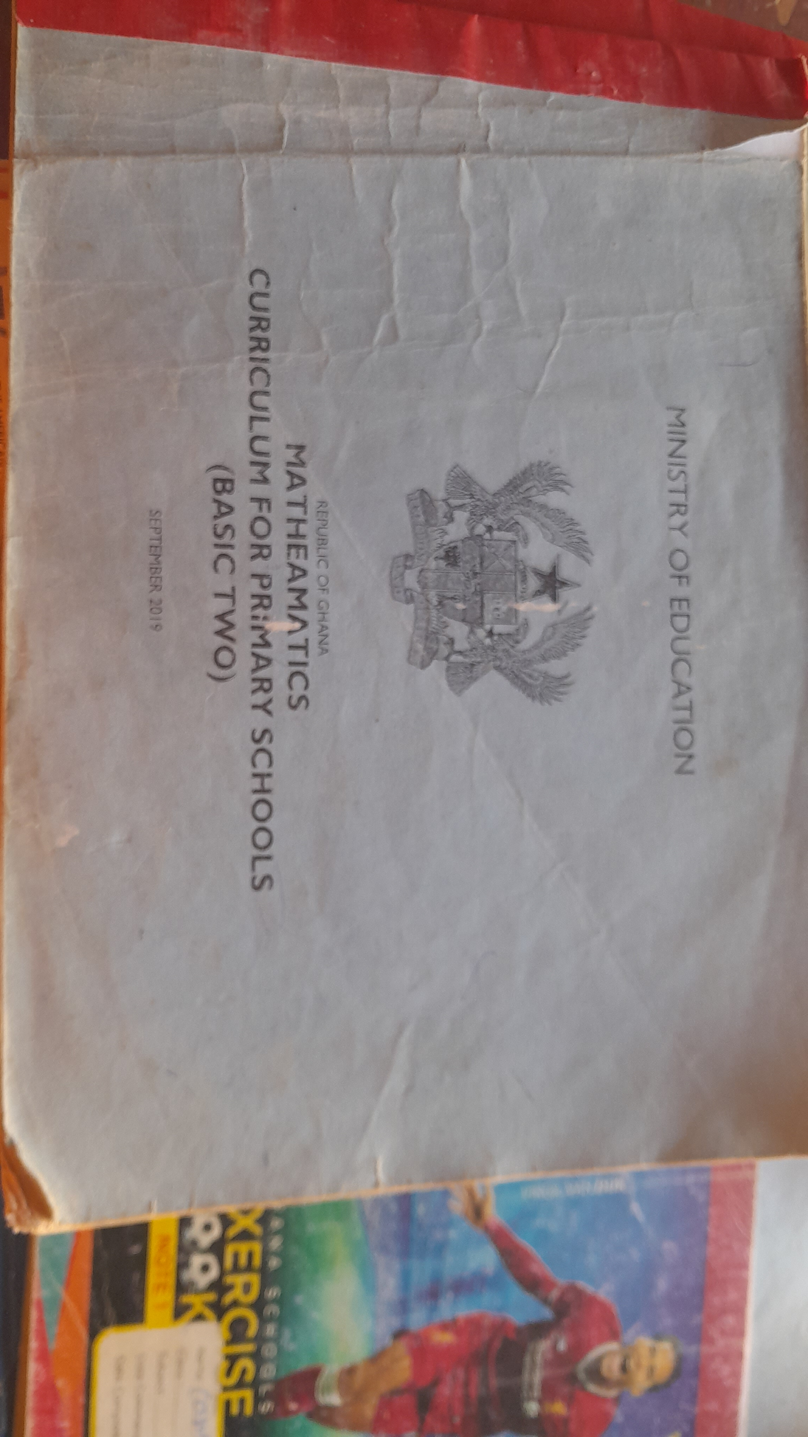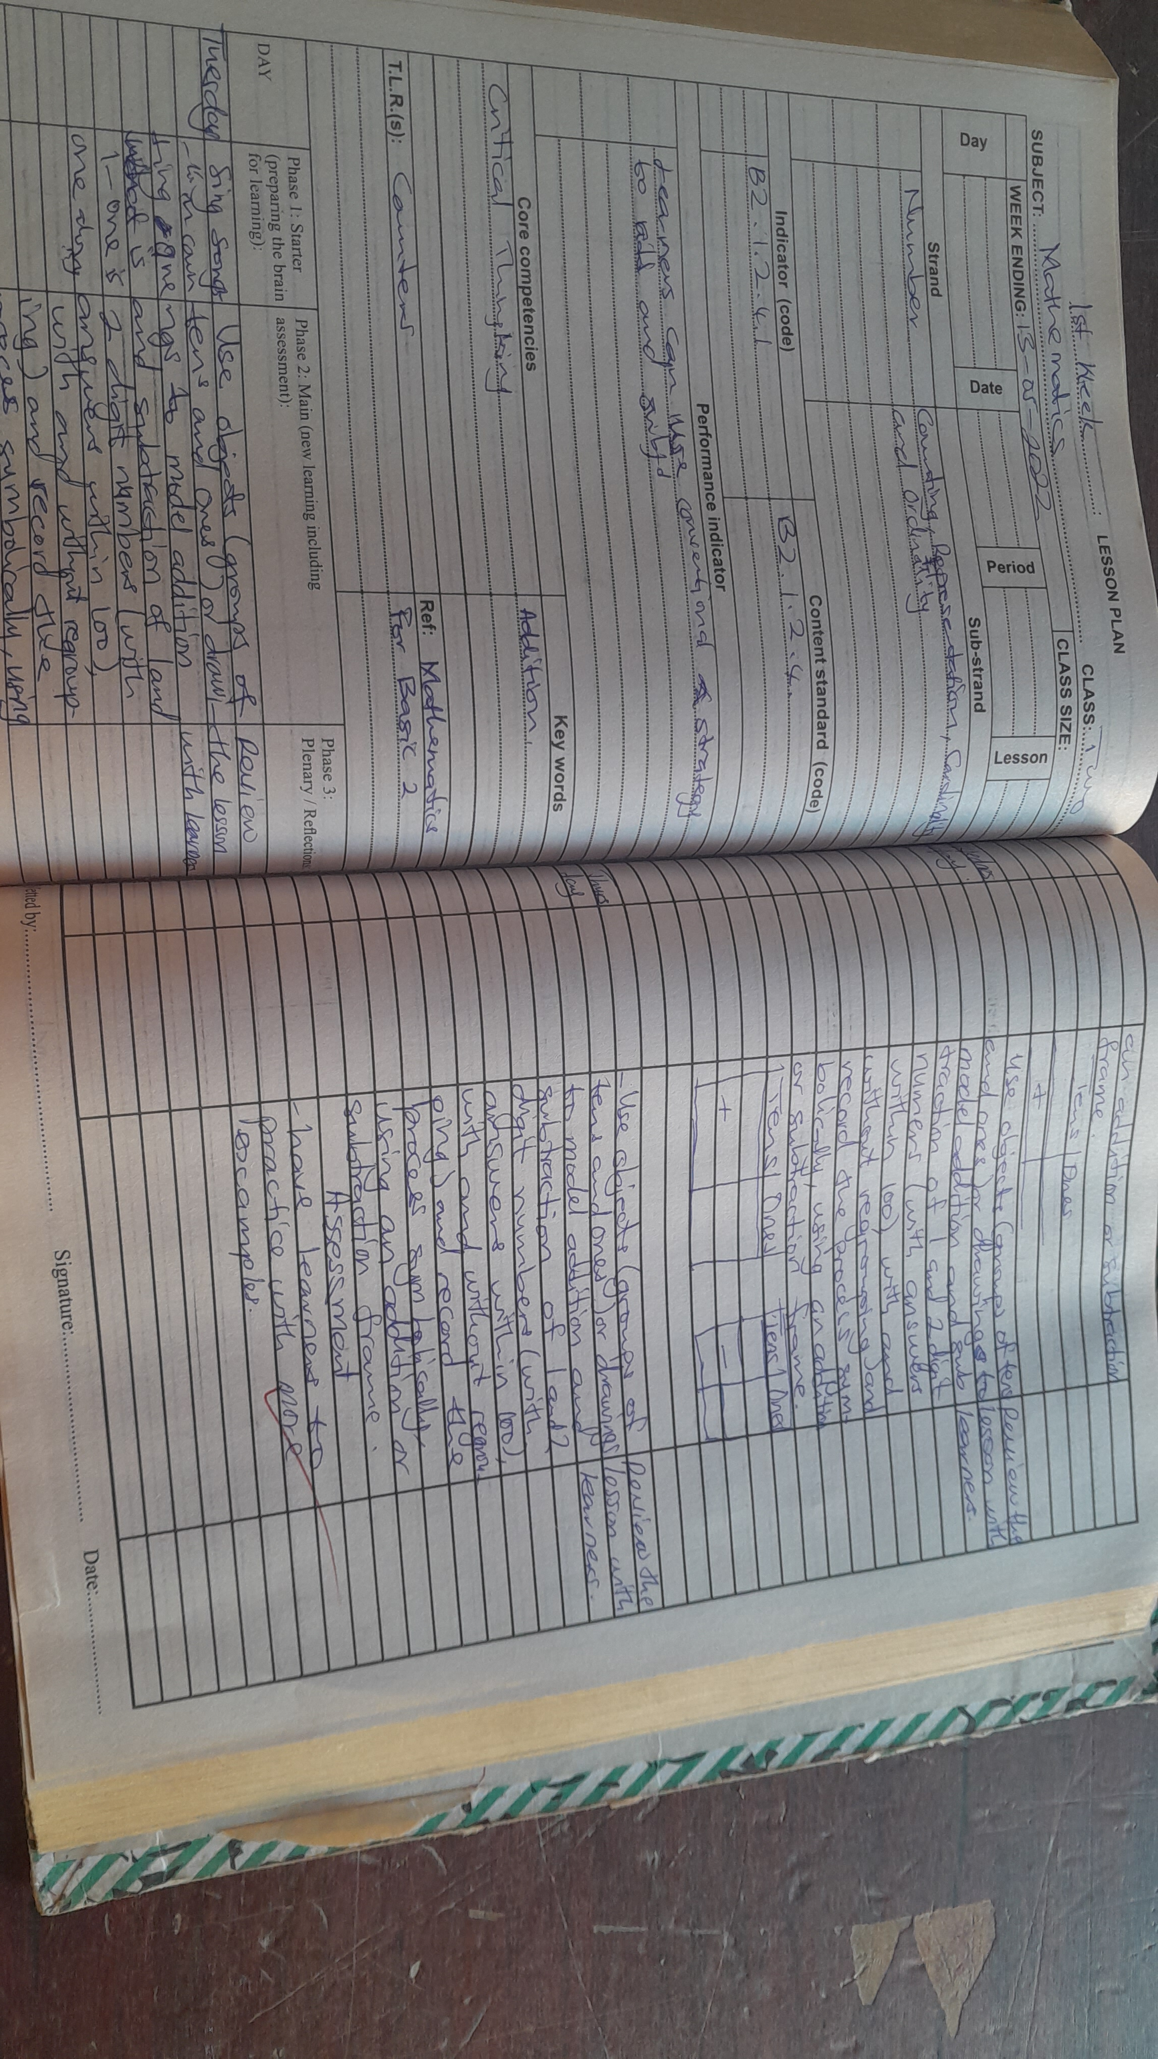 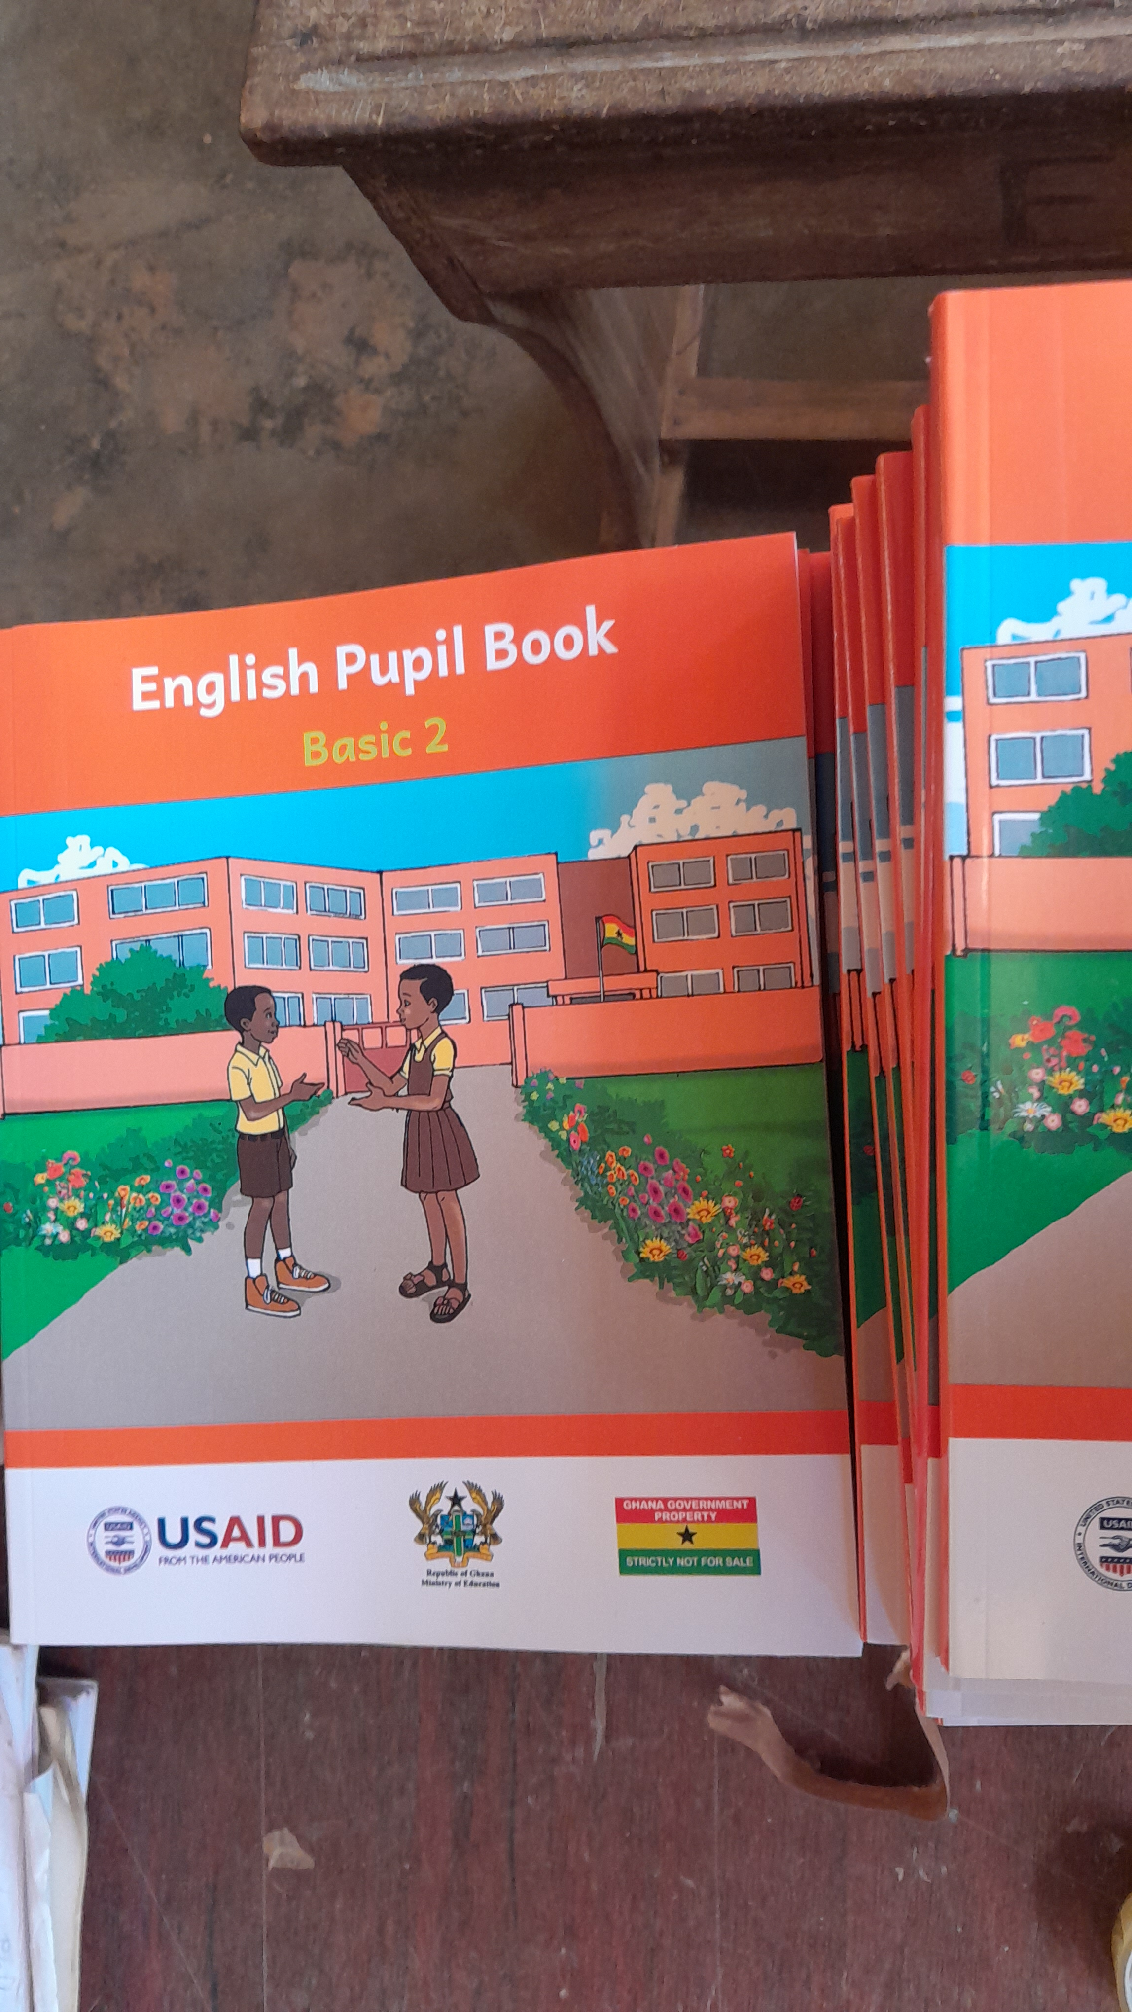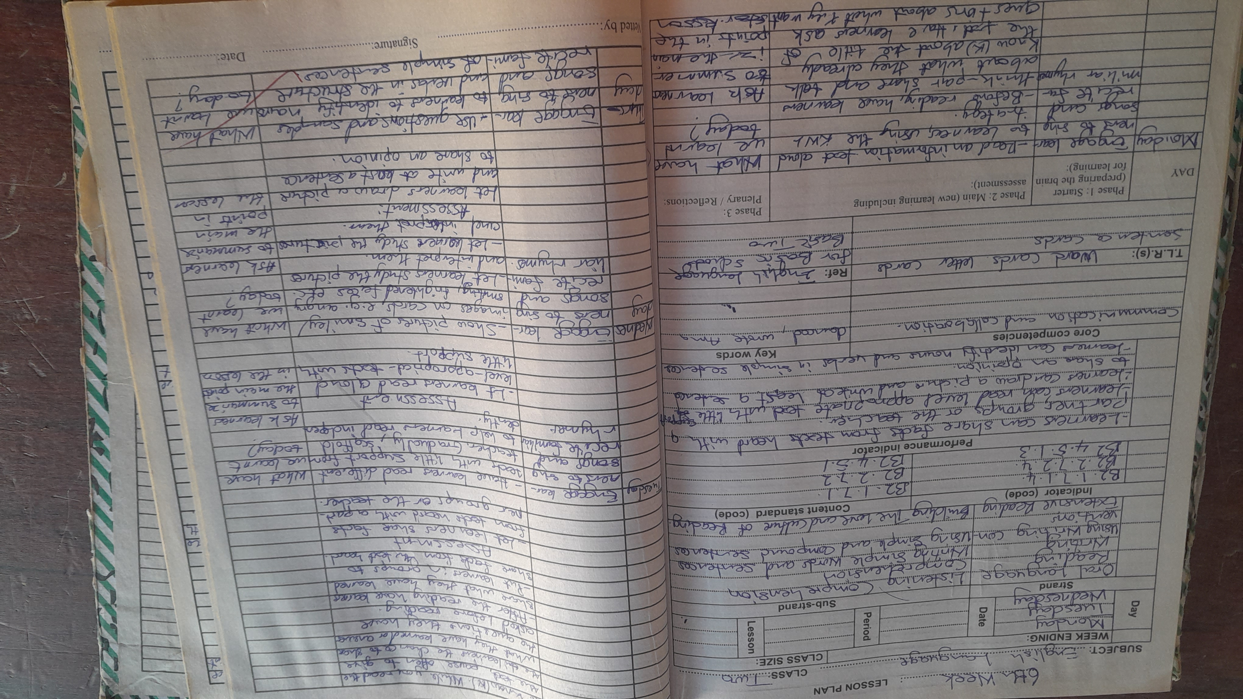 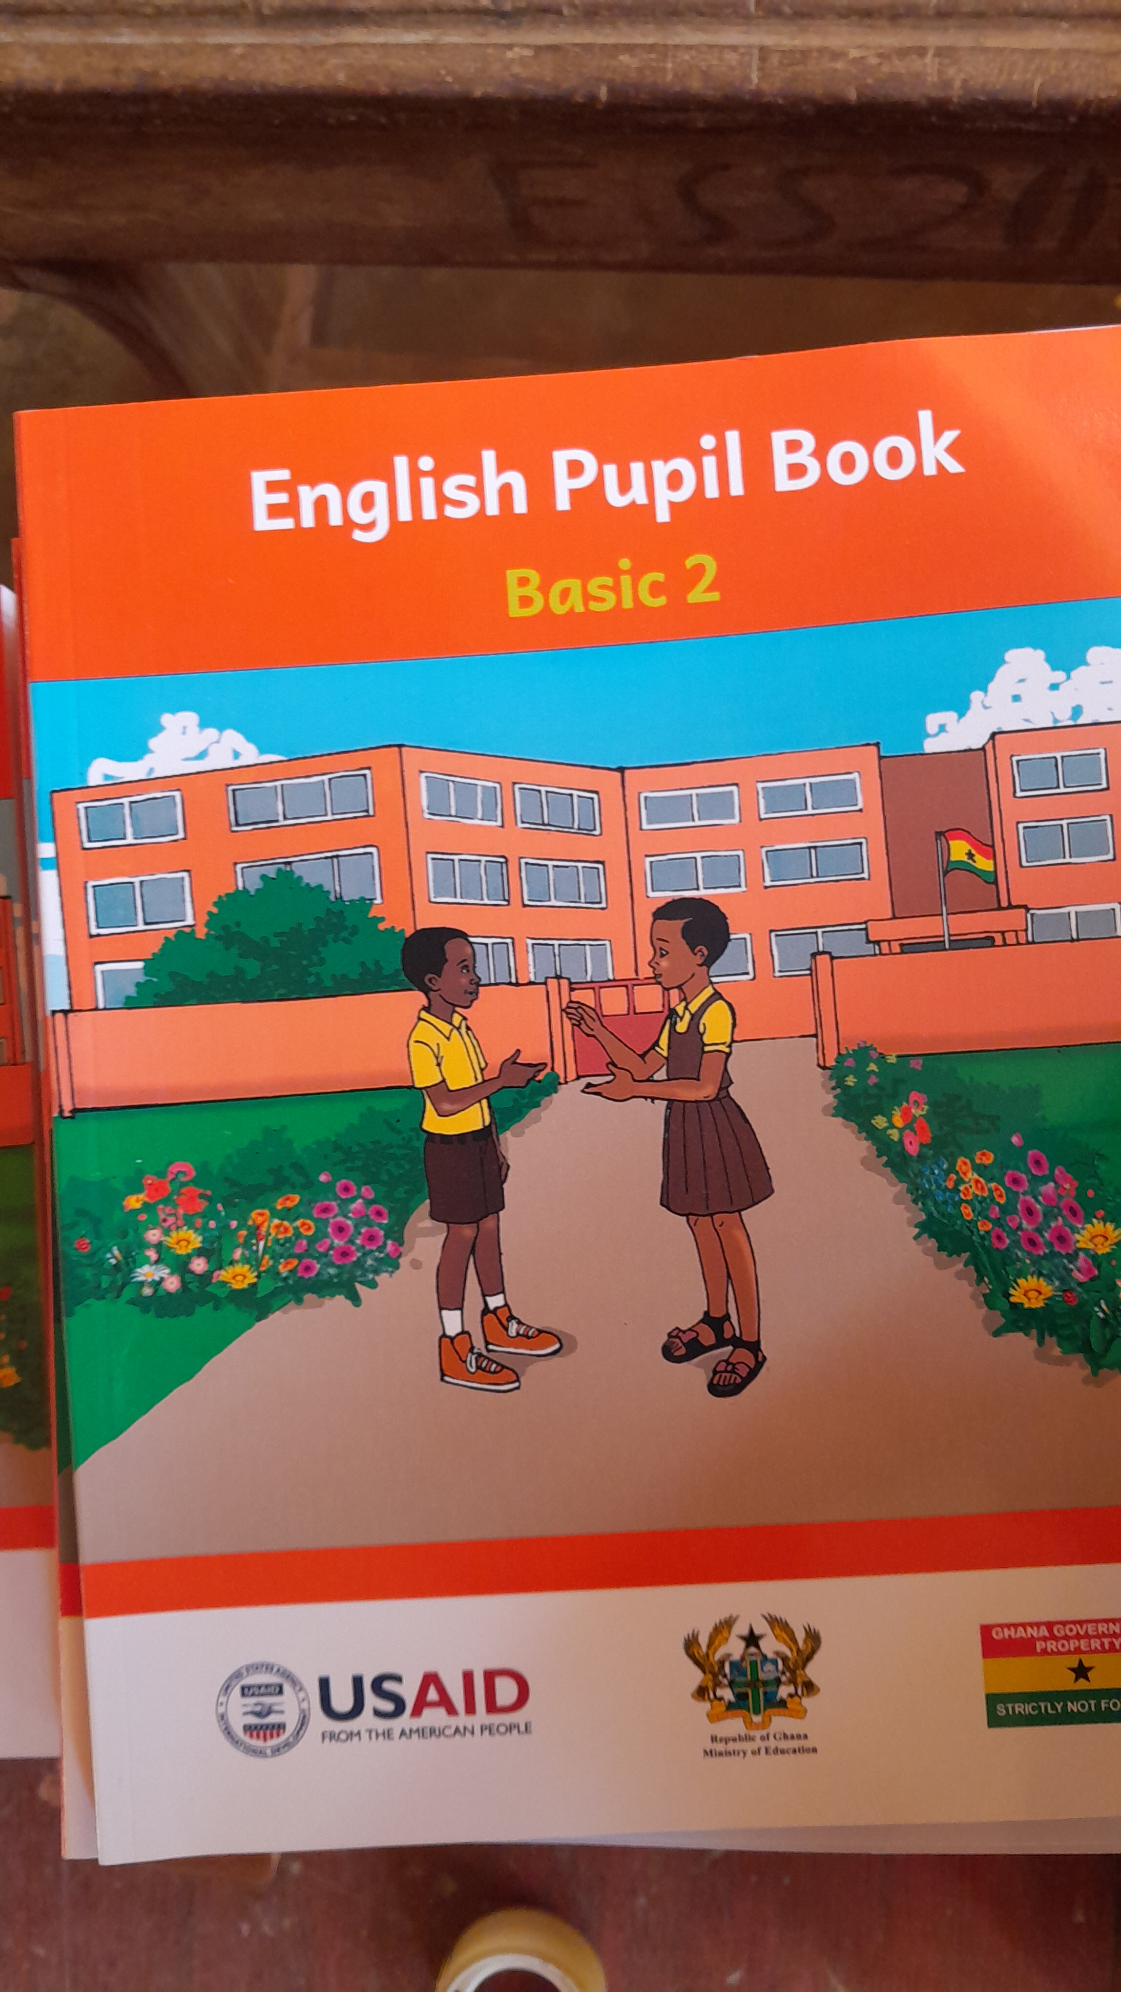

**WEEK TWO**

**OBSERVATION GUIDE ON LEARNER**

|  |  |  |  |  |
| --- | --- | --- | --- | --- |
| **ITEM** |  |  |  |  |
| **Physical Appearance of Learners** | **LEARNER 1** | **LEARNER 2** | **LEARNER 3** | **LEARNER 4** |
| **State of Uniform** | Very good | Very good | Very good | Very good |
| **STATE of Foot wear** | Nice foo wear | Nice | Good | Nice |
| **Hairdo of learner(well kept or unkept)** | Well kept | Well kept | Well kept | Well kept |

**LEARNING NEEDS OF LEARNERS**

|  |  |  |  |  |
| --- | --- | --- | --- | --- |
| **Oral expression** | Very interactive | Very interactive | Very interactive | Very interactive |
| **Reading from boards/books** | Good | Good | Good | Good |
| **Writing** | Yes | Yes | Yes | Yes |
| **Working with numbers** | Yes | Yes | Not really | Yes |
| **Solving problems** | Yes | Yes | No | Yes |
| **Accessing TL resources** | Yes | Yes | Yes | Yes |
| **Using TL resources well** | Yes | Yes | Yes | Yes |
| **Creative works** | Yes | No | Yes | No |
| **Thinking independently** | Yes | Yes | Yes | No |
| **Hearing instruction from teacher** | Yes | No | Yes | No |
|  |  |  |  |  |

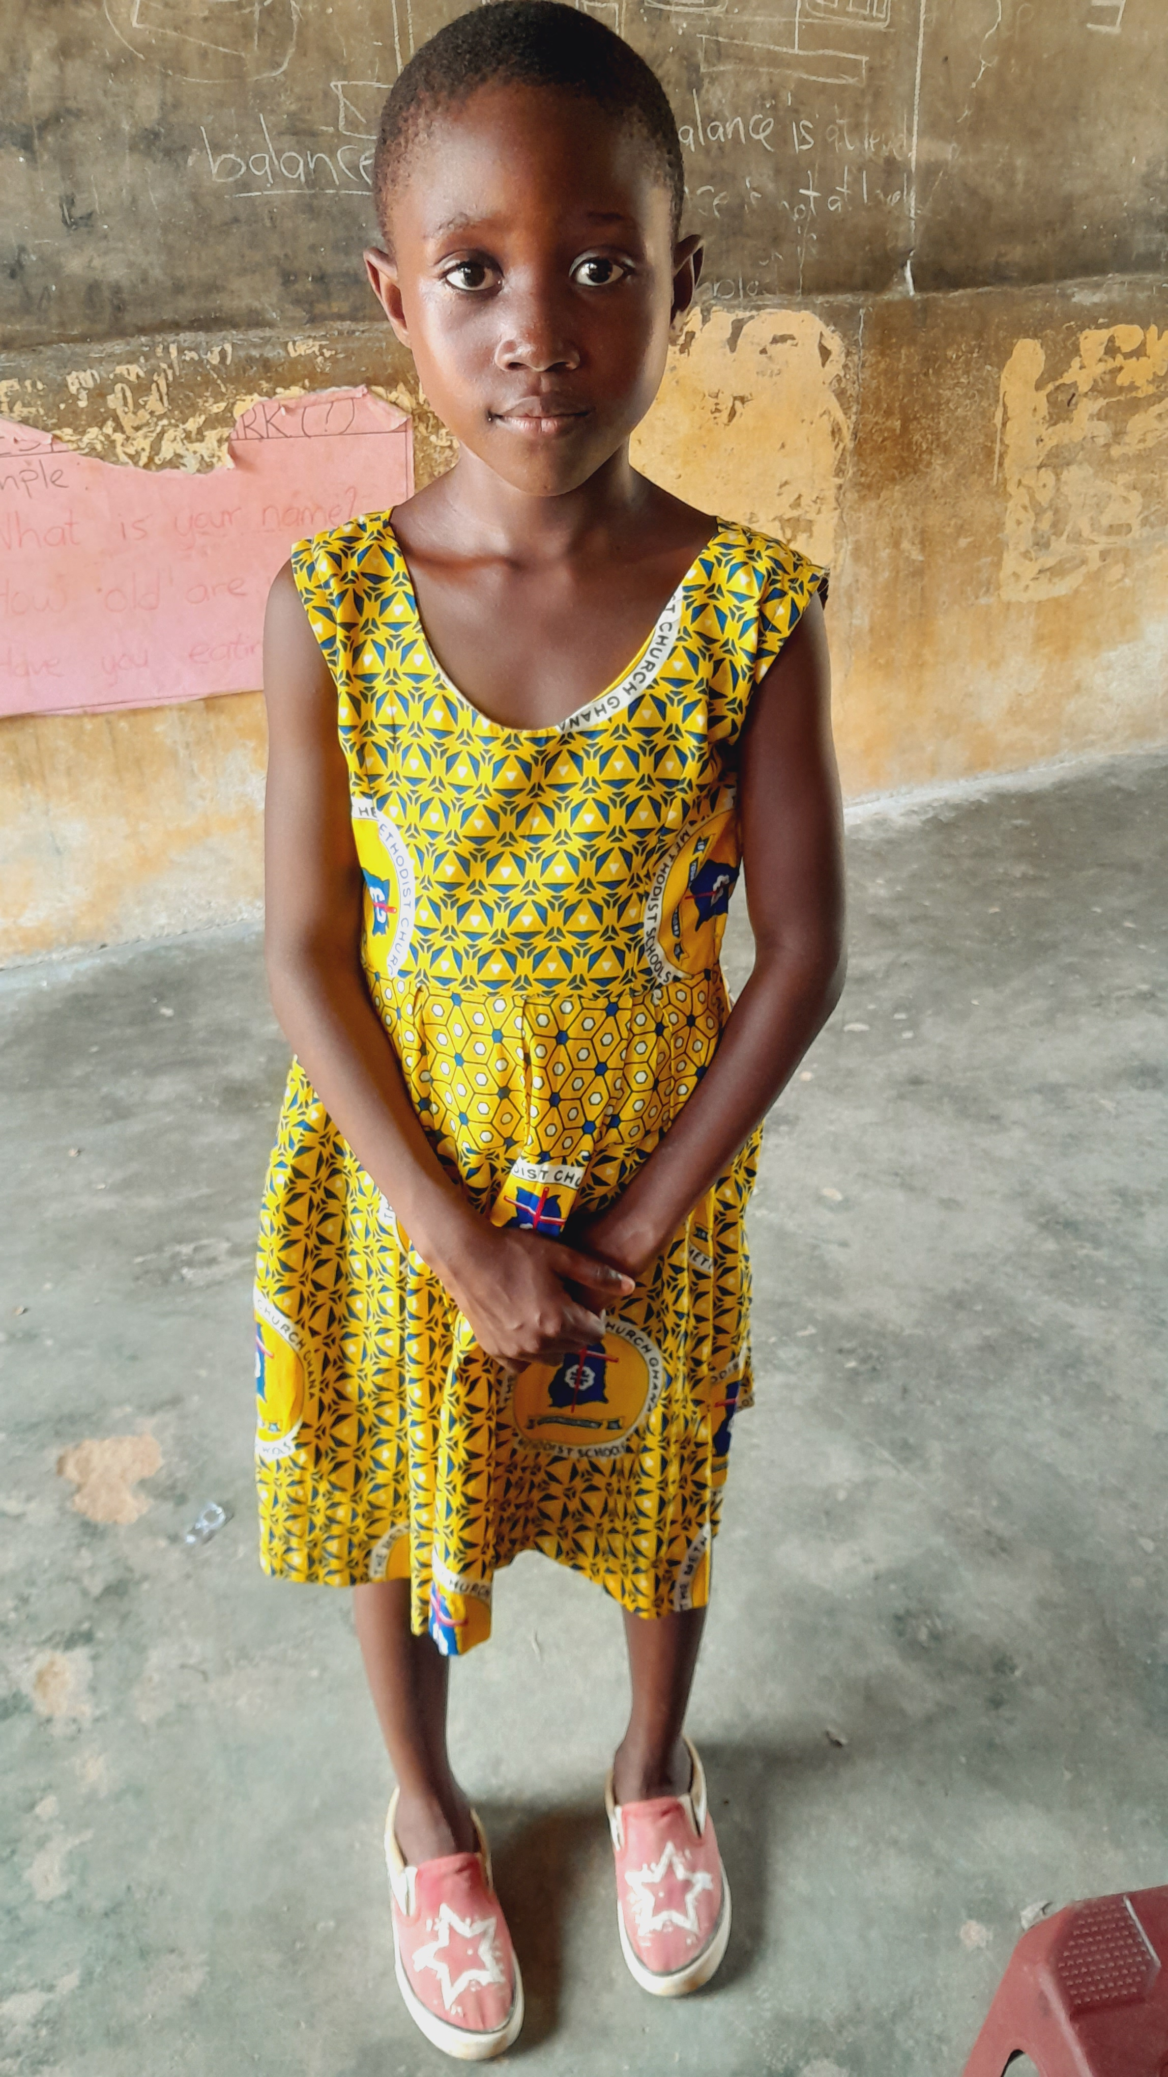 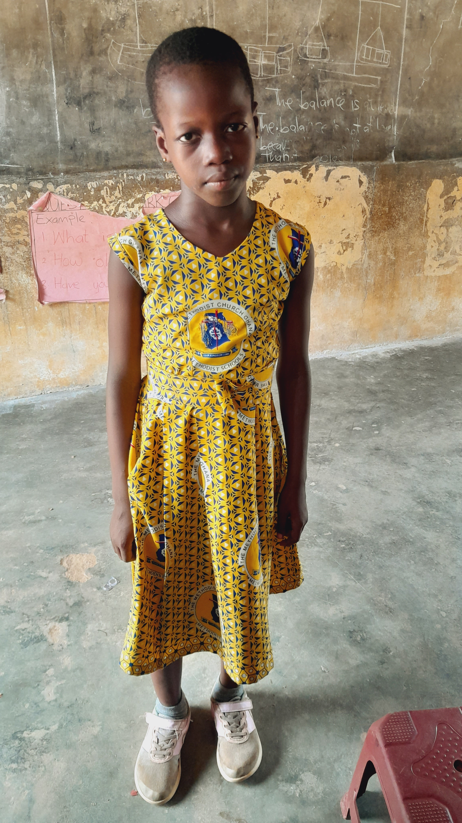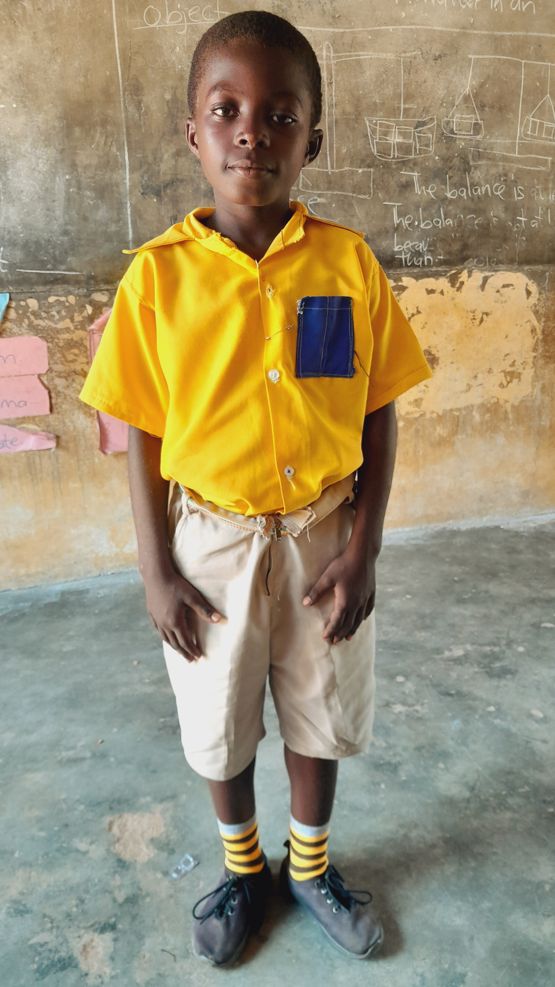 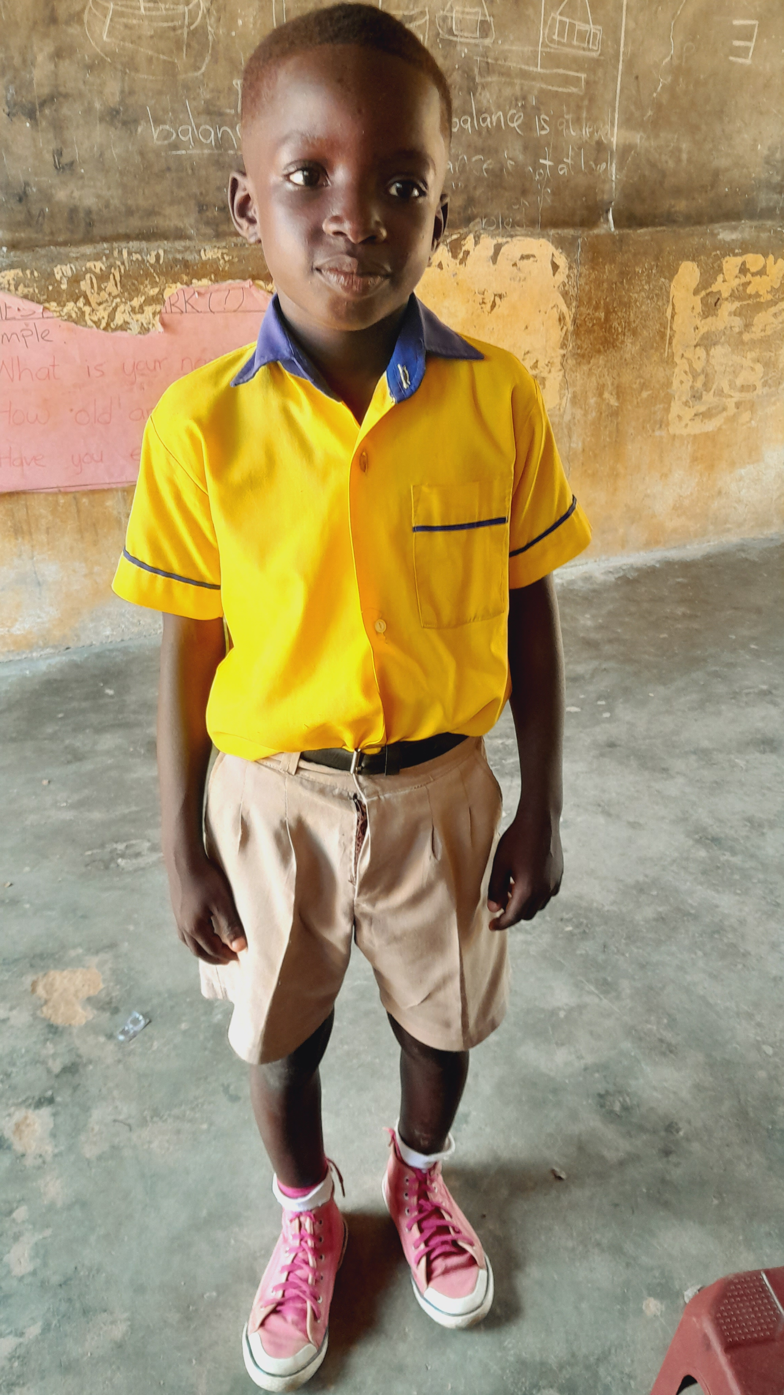

**WEEK THREE**

**LEARNING PROGRESS IN LEARNERS**

My mentor, Madam Lucy, uses both Fante and English in teaching. She teaches according to the timetable given to her, she always come down to thier level so that they can understand everything she's teaching. She also do both lecturing and practicing in teaching. The students also learn and work in groups and individually.

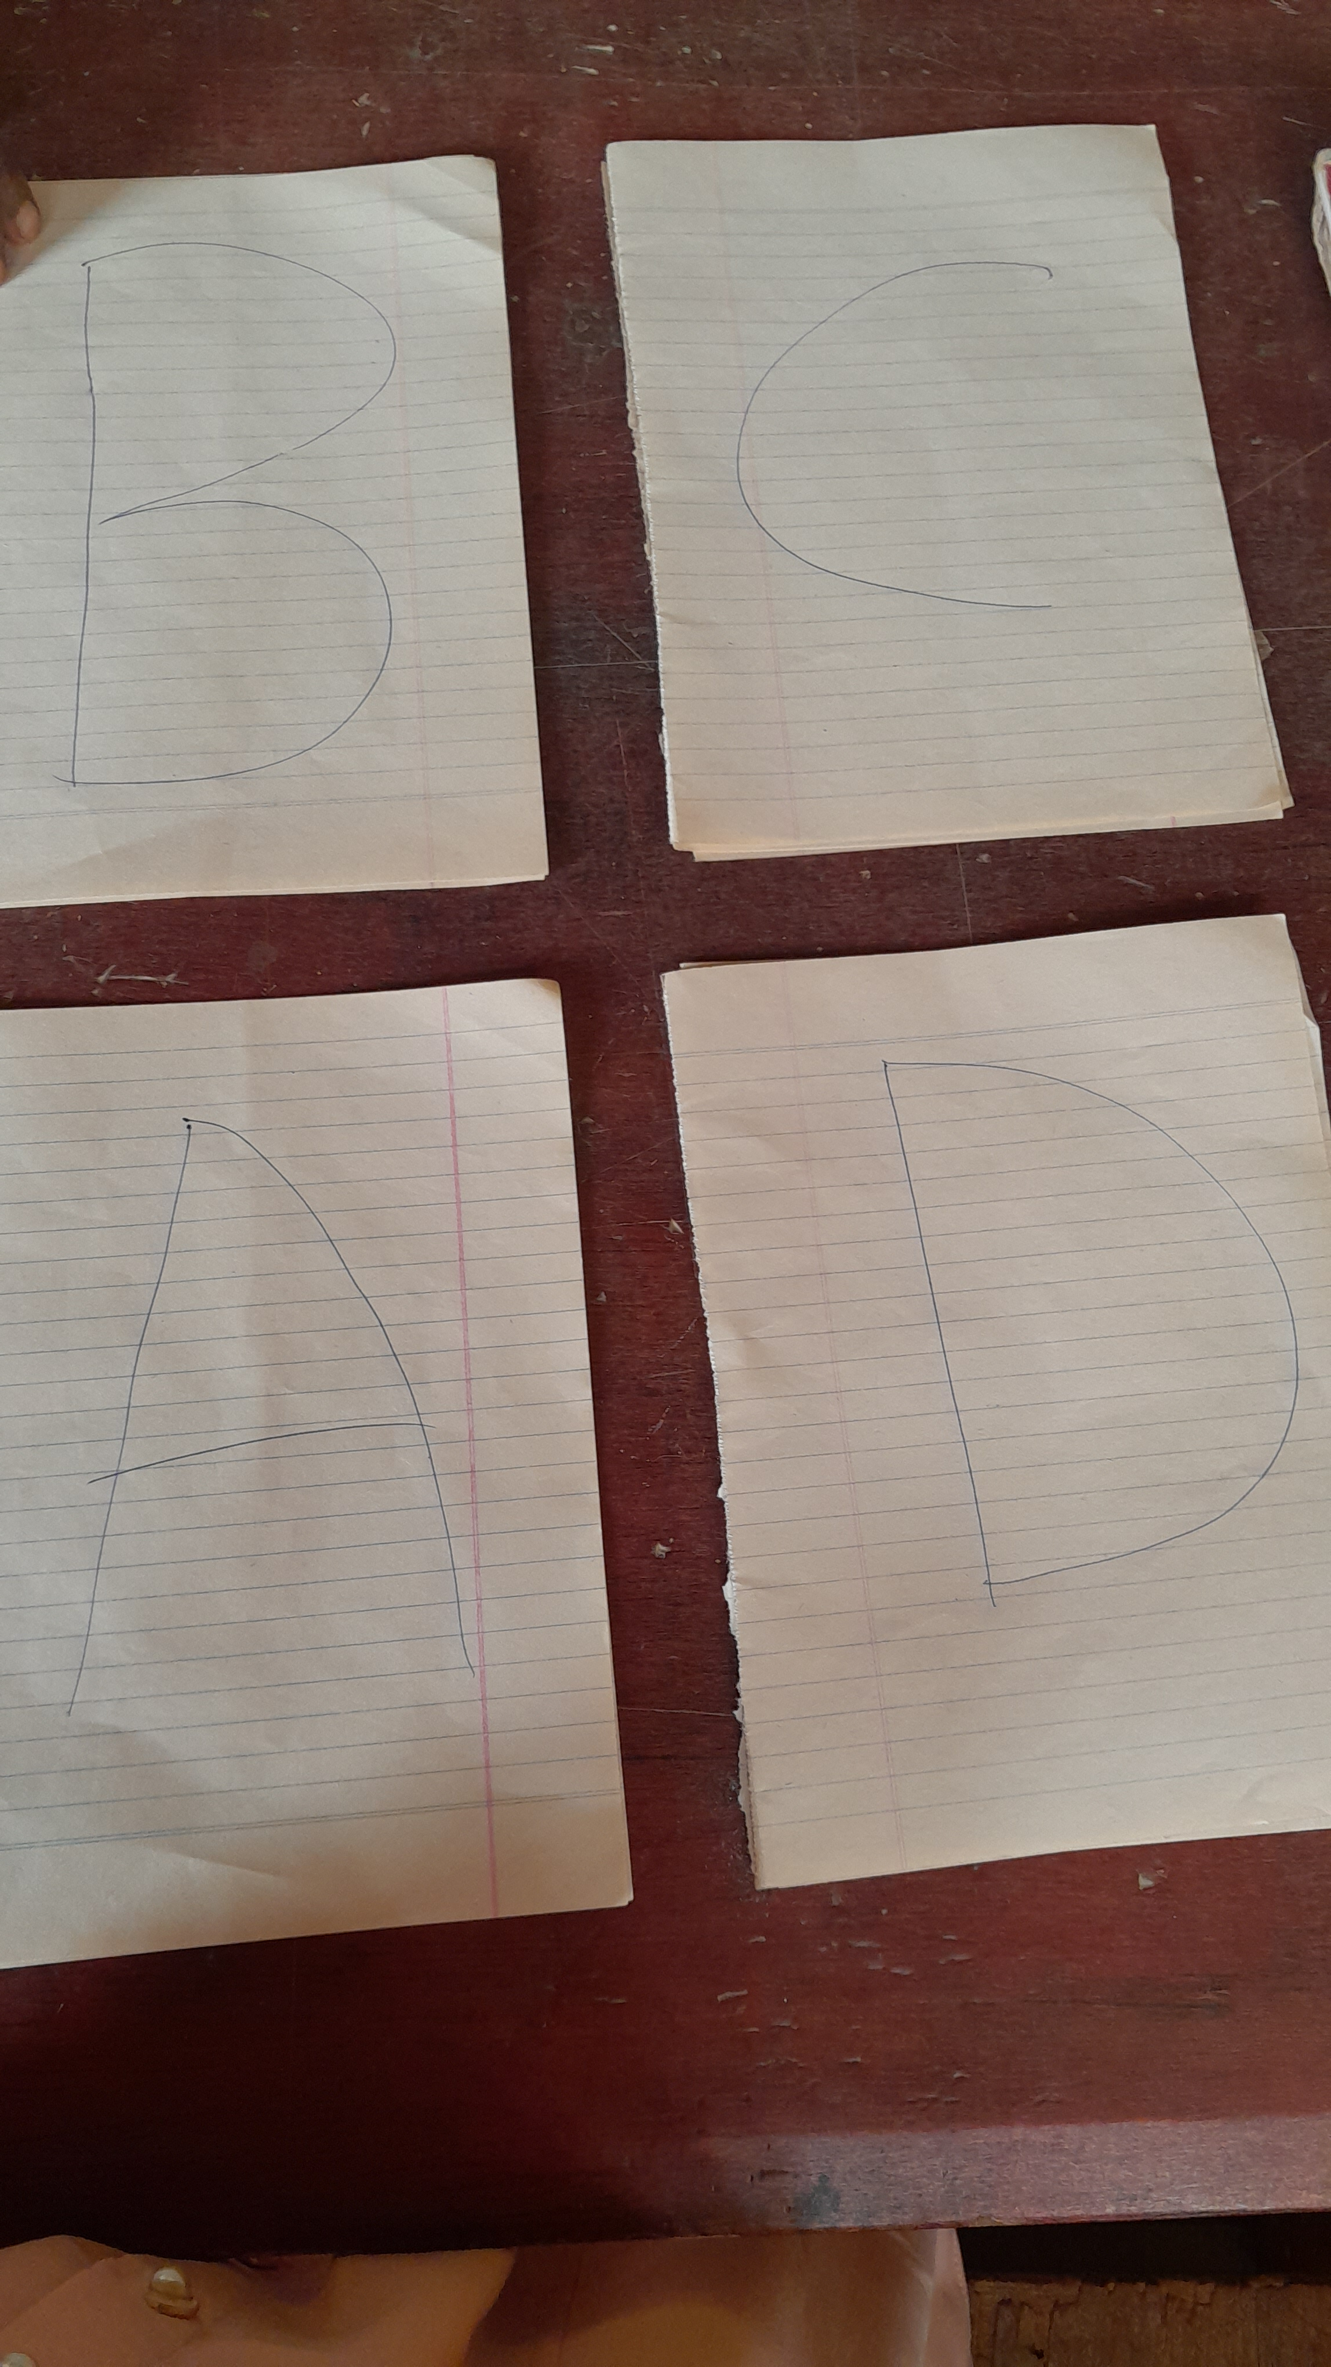**SOME PRACTICAL ITEM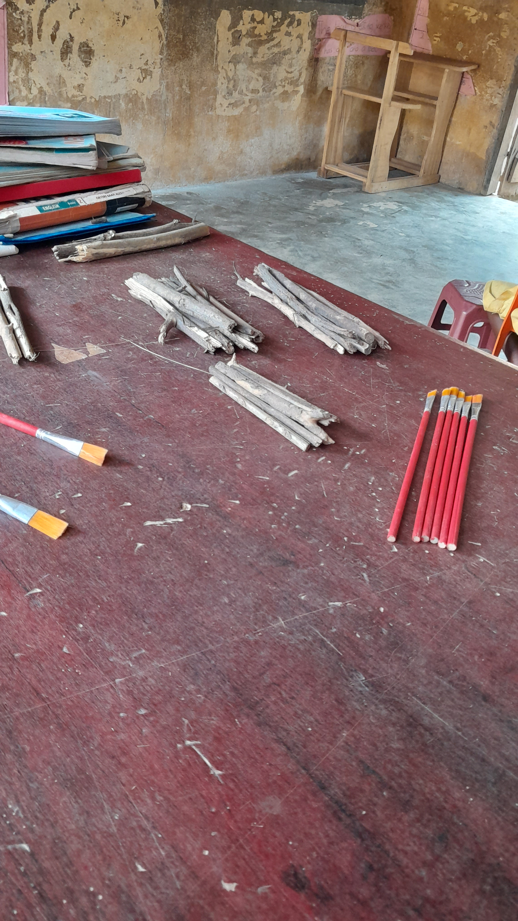SOME PRACTICAL INSTRUMENTS 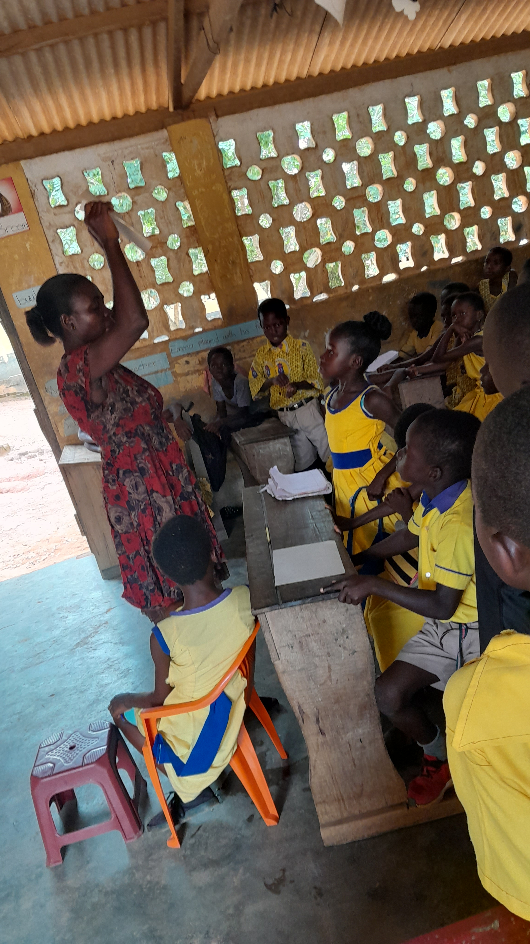 USING PRACTICAL IN TEACHING 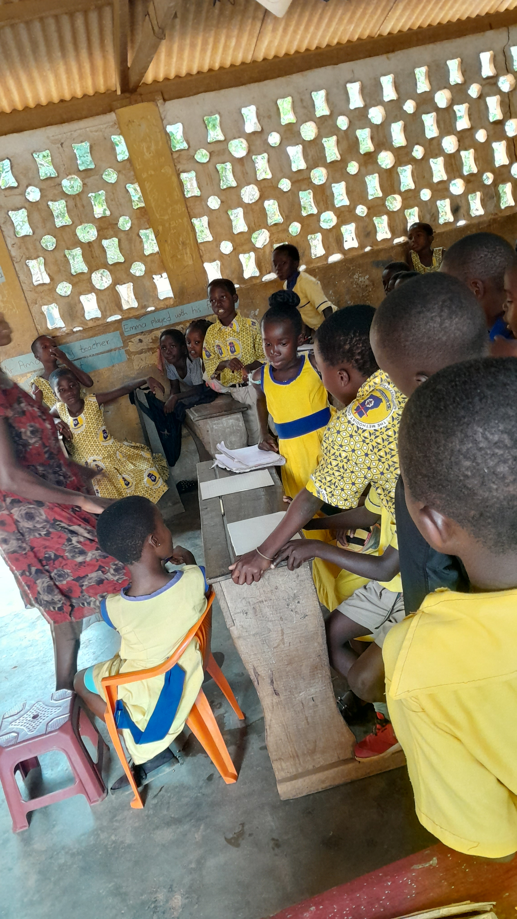STUDENTS OBSERVING 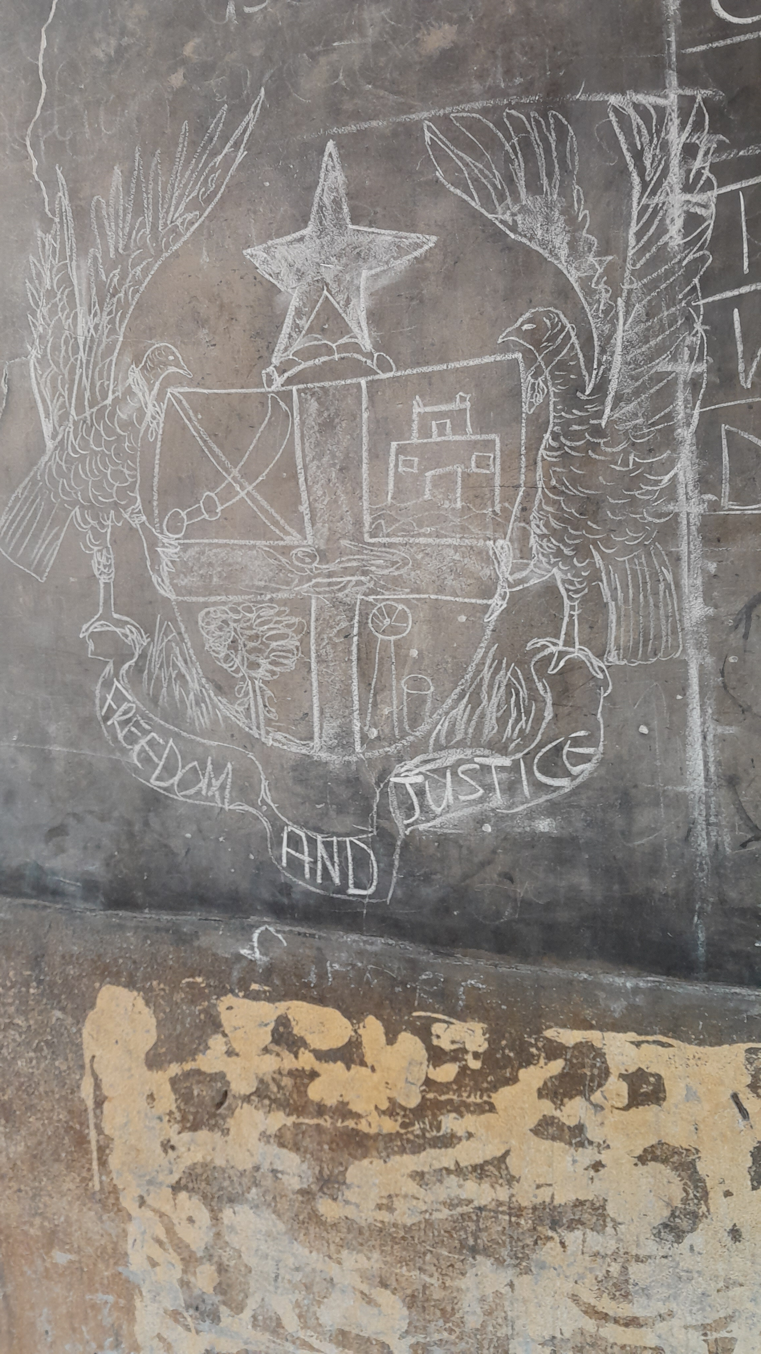DRAWN BY THE MADAM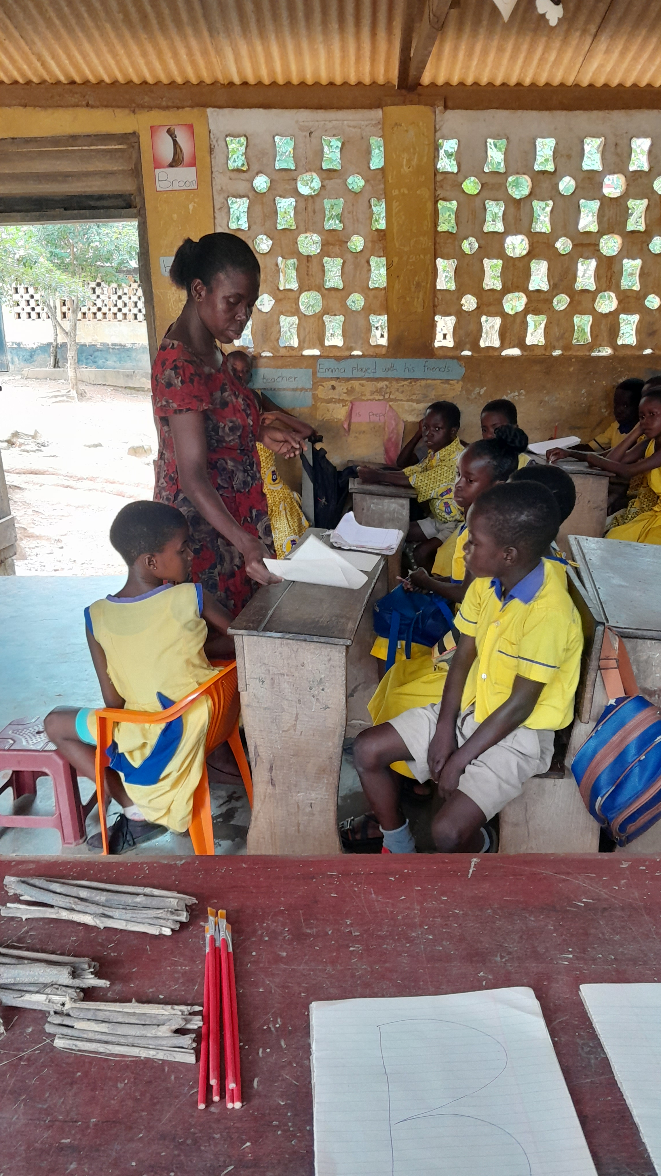STUDENTS OBSERVING**

**THE RELEVANCE OF ARTEFACTS TO TEACHING AND LEARNING**

In my observation, I saw that artefacts helps teachers to be able to address the diverse needs of learners. Learners with various learning styles are also able to participate lesson periods.

It asloo serves as an experience to children as addition to the various learning styles which then leads to higher levels of engagement and better retention.

Due to that, the students were able to progress in the following;

|  |  |  |  |  |
| --- | --- | --- | --- | --- |
| **Ability to read (early grade)** | Yes | Yes | Yes | Yes |
| **Ability to calculate** | Yes | Yes | Yes | Yes |
| **Able to meet curriculum content standard** | Yes | Yes | Yes | Yes |
| **Raises hands up to answer questions** | Yes | Yes | Yes | No |
| **Participate in class discussion** | Yes | Yes | Yes | No |
| **Participate in group work** | Yes | Yes | Yes | Yes |

**LEARNERS BEHAVIOUR IN CLASS**

|  |  |  |  |  |
| --- | --- | --- | --- | --- |
| **Come to class on time** | Yes | Yes | Yes | Yes |
| **Responds to teachers call** | Yes | Yes | Yes | Yes |
| **Disturbs in class** | No | No | No | No |

**WEEK FOUR**

**ANALYSIS OF DATA COLLECTION AND WRITING OF REPORT ON THE LEARNING PROGRESS OF LEARNERS**

At the end of my semester break observation, I with my mentor organize five tests to see how the learners have improved.

The score is out of 20

|  |  |  |  |  |
| --- | --- | --- | --- | --- |
| **Test** | **Learner 1** | **Learner 2** | **Learner 3** | **Learner 4** |
| 1 | 12 | 11 | 13 | 12 |
| 2 | 14 | 13 | 15 | 13 |
| 3 | 16 | 15 | 17 | 15 |
| 4 | 18 | 17 | 18 | 17 |
| 5 | 20 | 19 | 20 | 19 |

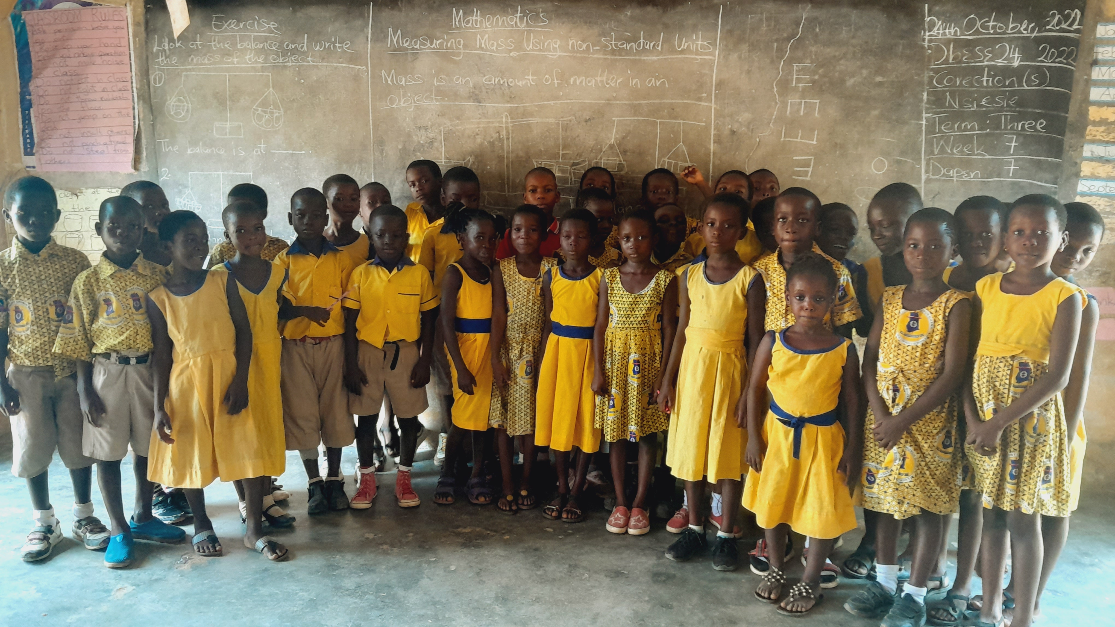 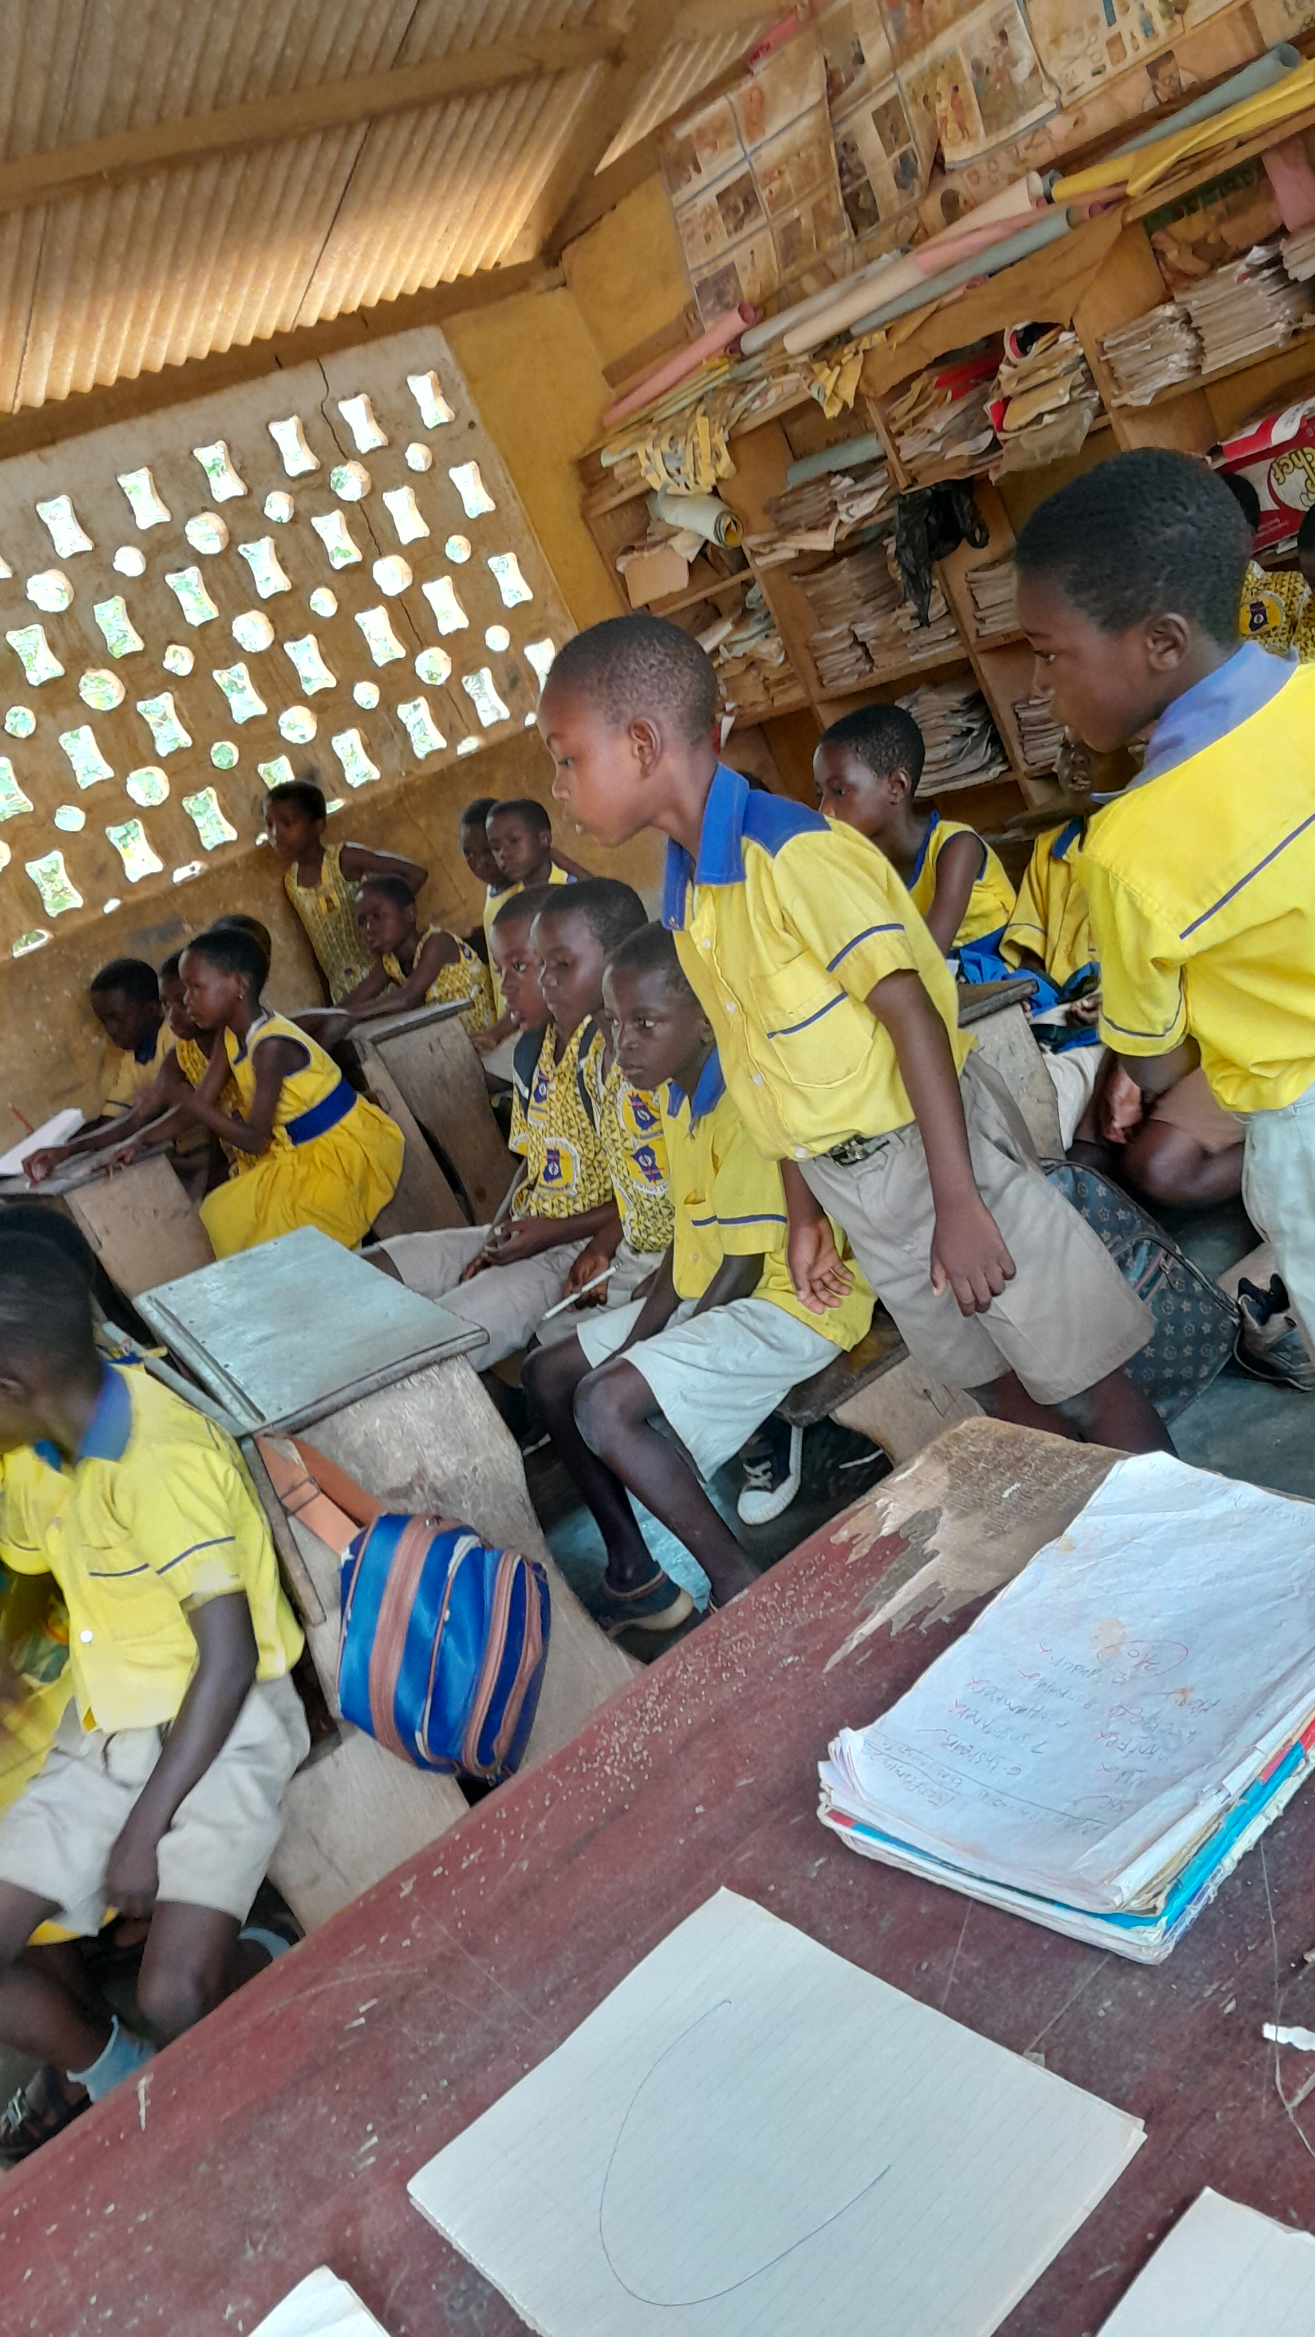

**THE ENTIRE CLASS**